**Final Project Report**

**Predictive Models for Anticipating Customer Churn in the Banking Industry**

By

RAGUL S

for the course of

Data Science with Data Analytics and Artificial Intelligence,

**Advisor**_________________________

**Date____________________________**

# ABSTRACT

In this digital environment, machines can understand human activities and what humans do. This ability of machine learning techniques can be in various sectors and various applications. One of the particular sectors is predicting the banking industry. Predicting churning customers is a cutting-edge approach that predicts which customers change their bank account from one to another and are about to leave a specific one. We developed a web-based customer churn prediction application using the predictive model based on the Machine Learning technique. The methodology is followed by the CRISP-DM (Cross-Industry Standard Process for Data Mining) Methodology approach to ensure a systematic development process for the bank industry. Machine Learning models like Random forest, Extreme Gradient Boosting, Histogram-based Gradient Boosting, Gaussian Naïve Bayes, and Decision Trees. This approach is implemented in large organizations that are concerned about their customers.

***Keywords: Customer Churn prediction, Machine learning techniques, Random Forest, XGB, Accuracy, Banking industry.***

# TABLE OF CONTENTS

ABSTRACT ii

TABLE OF CONTENTS iii

LIST OF TABLES vi

LIST OF FIGURES vii

Basic Project Information 1

Project Title 1

Client Name 1

Problem Definition 1

Project Objectives 2

Project Team 3

CHAPTER I: Introduction and Project Overview 4

CHAPTER II: Literature Review 6

CHAPTER III: Theory and Background 9

Introduction 9

Project Development Process: 9

Project requirements and specifications 11

Project Modeling and Design 14

Project Testing 15

Budget 16

Security and Privacy Concerns 17

CHAPTER IV: Implementation Analysis 19

Project analysis and design 19

About dataset 20

Configuration 21

Data preprocessing and Cleaning 21

Feature Selection and Data Splitting 38

Machine Learning Model 39

Model Development 43

Model Training and Testing 46

Chapter V: Testing Process 62

Model Testing 62

Website Testing 64

CHAPTER VI: RESULTS 67

CHAPTER VI: Ethical Issues 70

Ethical issues and considerations 70

Issues addressed 70

Chapter XIII: Business Concerns and Needs 72

Business concerns and budget constraints 72

Learning outcomes 73

CHAPTER IX: CONCLUSION 75

REFERENCES 77

Appendix A 80

Project Pan and Launch Checklist Rubic 80

Code Snippet 82

# LIST OF TABLES

Table Page

Table 1 Hardware Requirements and Specifications 11

Table 2 Software requirements and specifications 12

Table 3 Data Requirements and Specifications 13

Table 4 Project Budget Estimation 16

Table 5: Test case for the website 65

# LIST OF FIGURES

Figure Page

Figure 1 Churn prediction using customer segmentation 20

Figure 2 Import Required Modules 22

Figure 3 Load the Dataset 22

Figure 4 Dataset Structure 23

Figure 5 Discriptive Statistics 23

Figure 6 Dataset Shape 24

Figure 7 First Five Rows in the Dataset 24

Figure 8 Checking Missing Values 24

Figure 9 Check for Duplicates 25

Figure 10 Geographies in Dataset 25

Figure 11 Count Plot 26

Figure 12 Count Plot for Selected Variables 28

Figure 13 Count Plot for Exited 28

Figure 14 Count Plot for Selected Variables 29

Figure 15 Histogram Plot 30

Figure 16 Histogram Plot for Selected Variables 32

Figure 17 Distribution of Exited in Dataset 32

Figure 18 Distribution of Exited in Dataset Using Count Plot 32

Figure 19 Visualize Relationship between Exited Column 33

Figure 20 Visualize Relationship between Exited Column for selected Column using Box Plot 35

Figure 21 Drop the Unwanted Column 35

Figure 22 Categorical Columns into Numeric Columns 35

Figure 23 Correlation Matrix 36

Figure 24 Distributed of Exited in Dataset using Count Plot. 37

Figure 25 Correlation Values in Sorted Order 38

Figure 26 Split Training Dataset & Testing Dataset 39

Figure 27 Build the Random Forest Model 40

Figure 28 Build the eXtreme Gradient Boosting Model 41

Figure 29 Build the Histogram-based Gradient Boosting model 42

Figure 30 Gaussian Naive Bayes 42

Figure 31 Build the Decision Tree Model 43

Figure 32 Random Forest Build Model 43

Figure 33 Extreme Gradient Boosting Build Model 44

Figure 34 Histogram-based Gradient Boosting Build Model 44

Figure 35 Gaussian Naïve Bayes Build Model 45

Figure 36 Decision Tree Build Model 45

Figure 37 Displays the accuracy of the Random Forest Model 46

Figure 38 Using Plot Function of Random Forest Model 46

Figure 39 Models report of Random Forest Model 47

Figure 40 ROC Curve of Random Forest Model 47

Figure 41Display the Extreme Gradient Boosting Model’s accuracy and roc score 48

Figure 42 Classification report of the Extreme Gradient Boosting model 48

Figure 43 XGB Classifier Model ROC Curve 49

Figure 44 Calculation of Histogram-based Gradient Boosting model’s accuracy 50

Figure 45Classification report of the Histogram Gradient Boosting Classifier Model 50

Figure 46 Histogram Gradient Boosting Classifier Model ROC Curve 51

Figure 47 Displays the Decision Tree Model’s accuracy 54

Figure 48Classification report of the Decision Tree Classifier Model 54

Figure 49 Decision Tree Model ROC Curve 55

Figure 50: Code for the About Page of the website 56

Figure 51: Outcome of about webpage 57

Figure 52: Code for the Home Page of the Website 58

Figure 53: Customer Churn predictor home page 59

Figure 54: Backend code with Flask 60

Figure 55 Displays the Data frame 62

Figure 56 All Models under Single Data Frame 63

Figure 57: AUC ROC Curve for All Models 64

Figure 58 Accuracy of Machine Learning Model 67

Figure 59: Result 1 for prediction 68

Figure 60: Result 2 for prediction 69

# Basic Project Information

## Project Title

Predictive Models for Anticipating Customer Churn in the Banking Industry

## Client Name

This project can be used by the banking industry all are changing their banking accounts from one to another and this is the reason for Customer Churn.

## Problem Definition

Nowadays the banking industries are facing customer attrition, which was the major revenue loss based on their expenses of bringing in new customers. The profitability is being sacrificed, the bank also needs to spend additional money to train new customers. The primary complexity is focused on the inability to predict and mitigate churn. For the client, customer attrition is posing a significant impact on profitability as well as creating an inability to maintain a customer base with loyalty. The timely interventions of banking applications are also affected by a lack of real-time insights into customer churn behavior, leaving vulnerability to the loss of primary clients to the competitor. Addressing customer churn becomes very important in the competitive market to maintain profitability and customer trust. The project tackles the complexity of customer churn by leveraging predictive models to analyze and Identify customers at risk from historical customer data such as account details, demographics, and transaction histories. Additionally, the project requires a dynamic system to predict a specific customer's probability of leaving the bank. Therefore, the problem statement is to develop a web-developed churn prediction system using predictive models and machine learning.

## Project Objectives

The major objective of the research project is to develop a web application and integrated predictive model that accurately detects that customers are at risk of leaving the bank in the future and about to switch to another bank [1]. The goals of the project include:

* To collect relevant datasets with customers’ historical data, transactional history, demographics, account status, etc.
* To undergo pre-processing techniques to clean the data and address missing values, outliers, and null values.
* To undergo normalization and transformation processes to improve the quality of data.
* To select and extract limited meaningful features that indicate the customers who are likely to churn.
* Implement and evaluate the machine learning Models with training, testing, and measuring the metrics like precision, accuracy, etc.
* Develop a user-friendly web-based application to allow banking staff to enter customer details as input and check the churn status.
* Integrate predictive models and web applications to accurately predict the churn probability.

## Project Team

|  |  |
| --- | --- |
| **Team Members** | **Role** |
| Avinash Balusu | Data Analysts, Developer & Tester |
| Sirishma Pudota | Project Manager, website developer, Marketing Team |

# CHAPTER I: Introduction and Project Overview

In this highly competitive world, customer retention is very important for the banking sector to attain its growth and profitability. This is because sometimes customers quit using the services offered by a particular bank for some time and end their connection with the bank, thereby switching to another bank. So, this customer churn is the major concern faced by the banking industry. Banks need to maintain a positive customer base to increase their revenue and help attract new customers by gaining trust. Maintaining long-term customer relationships is highly valuable for banks. Banks need to understand and manage customer churn to maintain financial stability and protect their reputation. It has been found that acquiring new customers seems to be expensive, and so it is better to retain the existing customers. In this report, it is discussed about accurately predicting customer churn, which is important for banks to maintain their profit. The report focuses on developing web-based churn prediction applications using various predictive modeling techniques such as random forest, histogram gradient boosting, decision trees, and extreme gradient boosting approaches. This prediction web application would help banks identify the customers at risk of leaving and also the strategies to retain the customers as well. In this project, Machine Learning models like Random forest, eXtreme Gradient Boosting, Histogram-based Gradient Boosting, Gaussian Naïve Bayes, and Decision Trees. These models are used for prediction accuracy; they can easily predict the anticipated customer churn in the banking industry.

The objectives of this project are as follows,

* To explore various machine learning models and select the suitable one that predicts accurately.
* To train the selected model and tune it with the dataset and to evaluate the model using various metrics such as precision, recall, accuracy, F1-score, and ROC.
* To compare the algorithms and choose the best one from the performance exhibited.
* To integrate the predictive model into a web application and real-time customer churn prediction.

# CHAPTER II: Literature Review

The study proposed by [2], it is examined the impact of customer segmentation on the accuracy of customer churn prediction in the banking sector with the use of machine learning techniques. Nowadays, most businesses face this problem of customer churn because the customers are dissatisfied with the products or services received. Customer churn hurts businesses as it would make huge losses, and decrease profit rates. It has been found that machine learning models would resolve this issue as they can successfully anticipate customer turnover. The machine learning approaches would indeed help in analyzing customers’ shopping behaviour and boost purchase rates. The author discussed various machine learning models such as logistic regression, decision trees, k-means clustering, k-nearest neighbours, random forest, and support vector machines to predict customer churn. A dataset is obtained and pre-processed to improve the data quality [2]. Clustering techniques are being used to segment the customers into various categories. From the result analysis, it has been found that the dataset performs well using the random forest method with an accuracy of about 97%. Another model which is best in churn prediction is support vector machines. The key findings of this article are that customer segmentation does not have a great impact on prediction performance and that customer segmentation has no impact on anticipating customer attrition. And so it is dependent upon the models and the datasets chosen. The research field on customer churn prediction has classifications in various machine-learning models and these are works and provide a current state and future directions of churn prediction methodologies. The machine learning techniques for predicting customer churn within the banking sector as the article [2]**,**of machine learning techniques, is particularly Random Forest in the banking sector as the author approaches the employing the CRISP-DM methodology. It provides the structural framework for customer churn prediction to ensure each step from data collection to the model evaluation. The use of Random Forest is known for its robustness and the ability to handle large datasets with high accuracy and is very effective in predictive. This study emphasizes the systematic development of the at-risk customer churn banking prediction. The article [3]classified and conducted a comparative analysis of multiple classification models to evaluate the predicting customer churn efficiency. The model has been tested to integrate with Random forest and emerged as the most accurate, boasting a prediction accuracy of high-value rates. The high level of accuracy in handling Random Forest’s superiority in the dataset is used to capture intricate patterns within the data. Research from the author contributed to the customer churn predictions by providing evidence of Random Forest’s Predictive capabilities and a strong choice of the preferred model for churn prediction in the banking industry. The focus on Deep learning techniques specifically Artificial Neural Networks (ANNs) is suited from the authors' perspective. This article [4] has encountered deep learning as the potential module for handling the complexity and volume of business data. The Deep Learning model provides the accurate prediction and the ANNs are evolving a predictive customer churn of prediction in various machine learning methods complemented by the advanced deep learning techniques. In the research in this article [5] the author discussed the merits of Decision Trees and the Random Forest model is applicable for customer churn in accuracy and in capturing complex patterns in machine learning models. The author contributed to this process because these methods provide potential insights to understand the dataset and combine for prediction by multiple trees to improve the overall performance. The research contribution is effectively utilized to decipher intricate churn patterns and provide valuable insights into customer churn in the bank industry. The article [6] developed a web-based application to predict the customer churn at the banks and it used models such as machine support vector machine, Random forest, and decision tree. The web application allows the user to enter the customer details and lists the models with the result of customer churn either the customer exits or stays [7].

According to the research article [8], customer churn prediction leverages machine learning algorithms through XGBoost and logistic regression algorithms. A user-friendly web application has been developed in the article using Flask, JavaScript, CSS, and HTML technologies, and the predictive tool is integrated [9]. The primary objective of customer churn who are likely to leave the company has been identified on the website by entering customer details. The accuracy rate of the prediction is 85% to 90%, with higher reliability and prediction that facilitates better decision-making for customer retention.

From the literature review, these studies highlighted the efficiency of machine learning and deep learning techniques in predicting customer churn within the bank. Through the discussion Random Forest is applicable for high accuracy and Artificial Neural Network has the potential of deep learning in handling the complex dataset with the value of decision trees and methods.

# CHAPTER III: Theory and Background

## Introduction

The project involves website designing and predictive model integration using machine learning techniques it is a subset of artificial intelligence that also requires a training algorithm—used to recognize patterns in data and make decisions based on the training dataset for making predictions. In this project, we will use Machine Learning techniques, where the model is trained to identify historical data to predict future outcomes.

## Project Development Process:

The development process for the project is based on the “Predictive Model for Anticipating Customer Churn” in the bank industry. The methodology is followed by the CRISP-DM (Cross-Industry Standard Process for Data Mining) Methodology approach to ensure a systematic development process [10].

**Business Understanding - Objective:** Define the project requirements from a business perspective.

The project goal is to reduce customer churn, increase growth and profitability and improve customer satisfaction. The project aims for success such as a reduction in chum rate and improvement in customer retention rates. The stakeholders include bank executives, customer service departments, and marketing teams.

**Data Understanding - Objective:** Collect the data to understand and identify the characteristics of issues.

The data collected the historical customer data including transaction history and engagement metrics. The Exploratory Data Analysis can perform the data distribution, understand the data, detect anomalies, and identify patterns. Evaluating the quality of the data and checking for missing values or inconsistencies based on the data quality Assessment.

**Data Preparation – Objective:** Clean the data and pre-process the data to make it suitable for modelling.

The data cleaning is used to handle the missing values and remove duplicates for correct inconsistencies. Create a feature that may improve the predictive model’s performance such as frequency of transactions, customer tenure, and average transaction value. Data splitting is used to split the data into training, testing, and validation to ensure unbiased model evaluation.

**Modeling – Objective:** Develop the predictive model using a Machine Learning Algorithm.

The chosen algorithm appropriate Machine Learning Algorithm based on the data characteristics such as decision trees, random forests, neural networks, logistic regression, and gradient boosting. Train the predictive model based on the dataset and optimize model hyperparameters using techniques like random search to improve the model’s performance.

**Evaluation – Objective:** Access the Predictive model’s performance and accuracy using appropriate metrics.

The model validation may evaluate the model on the validation dataset using metrics such as accuracy, precision, F1-score, recall and AUC-ROC. The model compared to the performance of different models is used to analyse the model’s error to identify improvement in the model’s limitations.

**Deployment – Objective:** To implement the model in monitoring the performance.

The deployment process includes a web application development using the Python Flask framework that helps to connect the website with the back end of developer predictive models. Website can be designed by using HTML, CSS, and JavaScript in the front end. The developing predictive models can be integrated into the application and enable the bank staff to predict customer churn dynamically through the interactive website. Additionally, it can be more useful for continuous monitoring [7].

The integrated predictive model into the bank’s existing systems and workflows enables the model to provide real-time customer churn. Continuously monitoring the model’s performance and updates is needed to maintain data [11]. The end users refine the model and improve the model’s effectiveness by collecting feedback from stakeholders.

## Project requirements and specifications

The project requirements and specifications are very important so that the implementation can be completed successfully by meeting the objectives and outcomes.

**Hardware Requirements**

Table Hardware Requirements and Specifications

|  |  |
| --- | --- |
| **Requirements** | **Specifications** |
| **PC** | Laptop or Computer |
| **Processor** | Multi-core Processors |
| **RAM** | At least 16 GB RAM |
| **Storage** | SSD with at least 1TB |
| **Graphics Processing Unit** | NVIDIA RTX 3080/300, Tesla V100 |

**Software Requirements**

Table Software requirements and specifications

|  |  |
| --- | --- |
| **Requirements** | **Specifications** |
| **Operating System** | * Windows * Linux (Ubuntu) |
| **Data Processing Tools** | * Pandas * NumPy * SQL |
| **Data Visualization tools** | * Tableau * Power BI * Matplotlib * Seaborn |
| **Programming language** | * Python and its libraries * R |
| **Machine Learning Libraries** | * Scikit-learn * TensorFlow * keras |
| **Integrated Development Environments (IDEs)** | * Jupyter Notebook * PyCharm * VS Code |
| **Database management systems** | * MySQL * PostgreSQL |
| **Website development tools** | * Flask * HTML * CSS * JavaScript |

**Data Requirements**

Table Data Requirements and Specifications

|  |  |
| --- | --- |
| **Requirements** | **Specifications** |
| **Demographics** | Basic Information from the bankers' side |
| **Transaction History** | * Transaction Amounts * Account Activity * Transaction History |
| **Customer Interaction** | * Customer service supports * Feedbacks |
| **Account Information** | * Account Type * Account Balance |
| **Behavioral Data** | RectifYing Online banking usage |
| **Web Interaction data** | Customer information is collected through the website and used for analyzing user behavior. |

## Project Modeling and Design

In this project, Machine Learning techniques and the predictive model are used to measure the performance, which involves designing a machine learning pipeline that includes data pre-processing, feature engineering, model training, model evaluation, and model deployment. The proposed model has different steps to reduce customer churn, increase the growth of the bank, and make profitability by the Cross-Industry Standard Process for Data Mining [12].

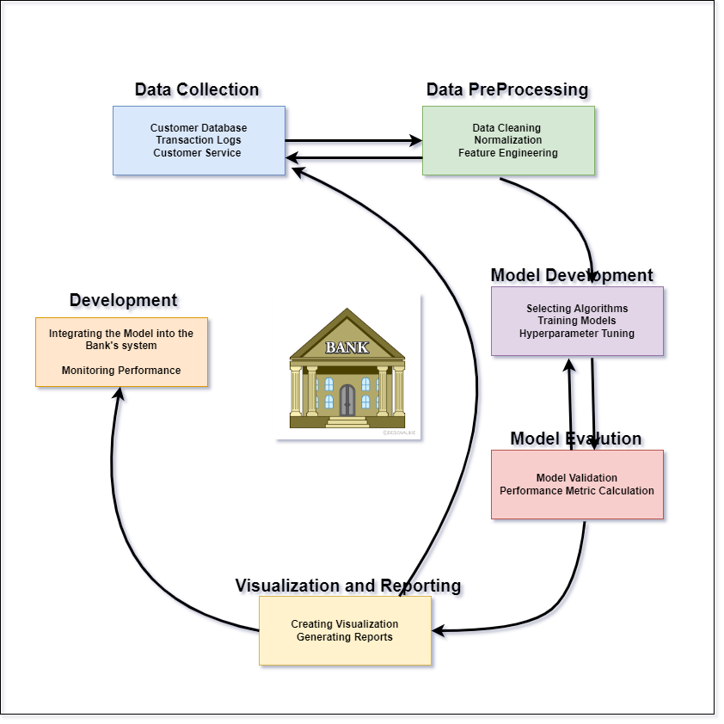

Figure 2 Predictive Model Development

Among various predictive analytics, where machine learning algorithms have been chosen as a solution to the problem mentioned in the earlier section of Cross-Industry Standard Process for Data Mining. The machine learning approaches have been chosen here because they can capture complex patterns found in data which is not possible by the traditional approaches. Customer churn prediction involves the analysis of customer demographics, customer behavior, transaction history, and interaction with the bank. Since banking datasets are huge and diverse and hold millions of records, machine learning algorithms are selected here which is capable of handling big data in a very efficient way. Also, machine learning algorithms like random forests, decision trees, gradient-boosted trees, and histogram gradient-boosting approaches are analyzed and built, trained, and tested. These algorithms show flexibility in handling different types of features like categorical, numerical, and text data. Once the model is developed by Python the website development for churn prediction is carried out. It includes A real-time churn prediction website is developed with user-friendly design. The website design is planned with two pages one is about the prediction homepage. A web application will gather the new customer data through user-friendly forms and streamline data ingestions into the developed machine learning-based prediction model pipeline [8]. The predictive model can be deployed with the platform using Flask and allows the user to real-time predictions dynamically. The About pages are planned to provide the usage and procedure of the website. So these machine learning approaches automate the process of model building and prediction thereby reducing manual errors and facilitating a better decision-making process.

## Project Testing

Testing in the project means that the performance of the built predictive model for customer attrition in the banking sector will work in the right and accurate manner. In the implementation stage, it identifies errors and identifying deviances and ineffective procedures in the implementation. These also comprise feature testing to check compliance with specific standards and reliability testing to prove model reliability in reference to specific conditions.

**Model performance testing**: The most commonly used statistics include the accuracy and precision, as well as recall and the area under the receiver operating characteristic curve. The robustness of the model is, however, achieved through a final check and performance audit whereby issues are corrected, and performance is checked to meet the best standards in the actual environment.

**Web application testing**: Manual testing techniques used to test the developed web application. The manual testing allows the user to enter the input manually into the developed user-friendly frames and evaluate each component of the web pages. It ensures the user input is properly captured, processed, and validated by the predictive model.

**Usability Testing**: Usability testing concentrates on the usability of the Web application interface and provides valuable feedback to improve the prediction process and streamline its operations.

## Budget

Table Project Budget Estimation

|  |  |
| --- | --- |
| **Project Phases** | **Cost in $** |
| Hardware | $3000 |
| Software Licenses | $1000 |
| Cloud Services | $2000 |
| Miscellaneous | $500 |
| **Total cost** | $6,500 |

## Security and Privacy Concerns

The predictive modeling project of the security and privacy concerns are revolving around handling sensitive customer information in compliance with legal and ethical standards and they are followed. Data breaches, this is because information that may be held about a client may be leaked to the public through such aspects as unauthorized access or cybercrimes [13]. Storage and Encryption, perceived weaknesses in the encryption of the data, either during transit or when stored could make data loss more probable. With the website integration, additional security measures are required to protect the new user data over the user interface. Between the web publication and the server, the network is used to transfer the data so that can be possible to occur data breaches. Since the website is accessible to the user unauthorized access to bank customer data can be possible. Model Integrity, it is demonstrated that threats such as adversarial attacks, can compromise the performance and reliability of machine learning models. Access Control, Lack of effective role-based access controls may lead to the outcome normally only visible or changeable by persons who do not have the right to work with the given information. Exposure of Sensitive Data, Personal details, financial, transaction, and other histories, and buying characteristics are examples of the type of customer data that cannot be allowed free flow of data on the internet. Regulation Compliance, A person should follow the stringent general data protection laws and regulations which include the GDPR or any other piece of legislation that governs a nation’s regional region [13]. The complaints protocols should be encompassed with the web applications for user data collection, processing, and retention. This involves getting the approval of the client and ensuring that we keep data to the minimal. Fairness and Bias forecast from reference of Biased data or Biased algorithms may harm a specific community or group of people. Data Transparency, It enables clients to be concerned with the way the models make use of the provided data and whether they understand the outcomes.

# CHAPTER IV: Implementation Analysis

## Project analysis and design

The project is mainly offered by a particular bank for some time and end their switching to another bank account. Customer churn is a major concern faced by the banking industry and the bank focused on developing a predictive model to anticipate customer churn in the banking industry using machine learning techniques. Customer Churn, where customers leave one bank for another may pose significant challenges to the bank’s growth and maximize profitability. By using the predictive model to identify at-risk customers early, then the bank can implement a target retention strategy to reduce Churn rates. This milestone reports on the progress made and includes completed modules such as Data-Pressing, Model Implementation, and Evaluation. From the previous evaluations, the modules and the processes particularly in the data cleaning process need to be improved and ensure the ethical handling of sensitive customer information throughout the project.

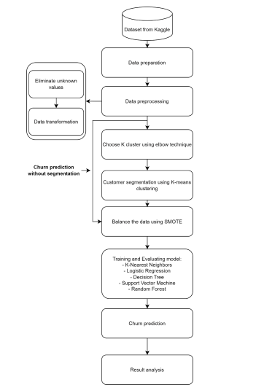

Figure Churn prediction using customer segmentation

## About dataset

Analyzing the bank churn through binary classification for customer churn dataset from Kaggle offers ideal for predictive modeling. The dataset consists of Age, Sex, Account Balance, Transaction Frequency, Churn status, etc., these are essential for building a robust model by analyzing these attributes to uncover patterns indicating that customers are more likely to churn. The dataset performed for training and testing of various machine learning models such as Random Forests or Artificial Neural Network models can achieve high accuracy in churn prediction by capturing complex relationships within the data. The Dataset’s behavioural patterns and transactions are indicators of customer engagement and potential customer churn is focused on the predictive model to mitigate churn risk. This dataset used in this project is sourced from Kaggle’s Customer Churn Dataset, It contains data about customers, including demographic details, transaction history, and account behaviour which is also a capability of customer relationship management for enhancing predictive modelling skills.

Dataset Link: <https://www.kaggle.com/datasets/harshitstark/dataset?select=train.csv>

## Configuration

**Tool and language used**

The tool that is used for implementation is Jupyter Notebook which is an open source simulation platform. The configuration of hardware with Multi-core processors, 16BG RAM and SSD. Software configurations are Python, Jupyter Notebook, Scikit-learn, Pandas, Numpy.

This simulation platform supports different programming languages by creating and configuring through code development. Similarly, the Python programming language is used which uses some of the in-built libraries like pandas, matplotlib. pyplot, seaborn, train_test_split, Flask etc. HTML, CSS, and JavaScript is used to develop the web application.

## Data preprocessing and Cleaning

In milestone 1, the project development process is carried out where the data is downloaded from the data source.

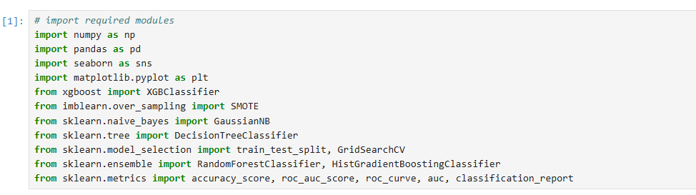

Figure Import Required Modules

Here, importing the required python libraries.

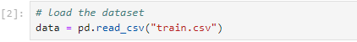

Figure Load the Dataset

Here, dataset has loaded.

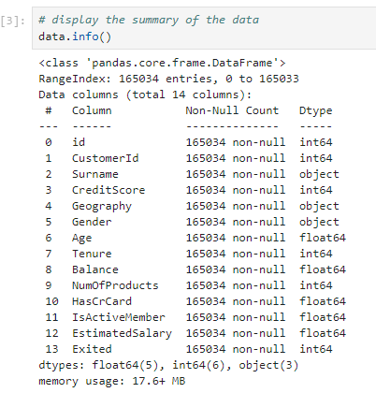

Figure Dataset Structure

Here, the above screen displays the internal structure of the dataset.

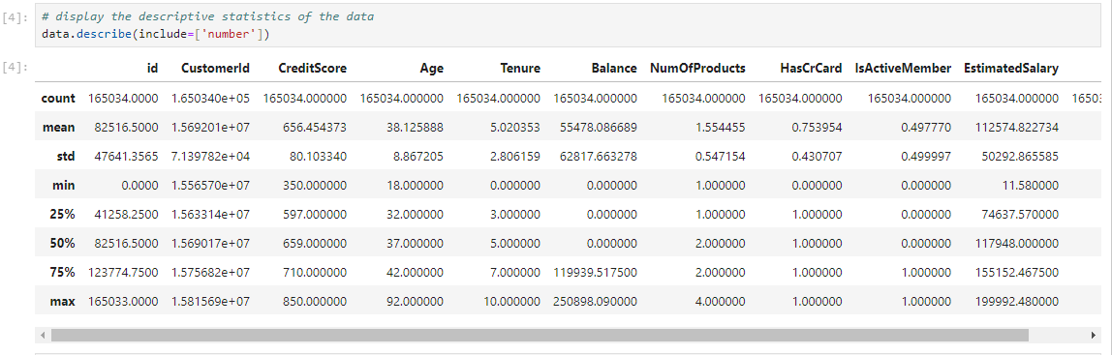

Figure Discriptive Statistics

This screen provides the descriptive statistics of the numerical column

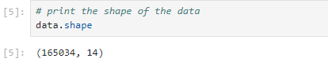

Figure Dataset Shape

Here, the above screen displays the shapes in the dataset, having 165034 rows and 14 columns.

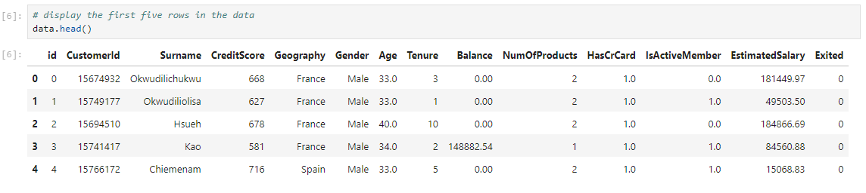

Figure First Five Rows in the Dataset

The above screen provides the first five rows in the dataset.

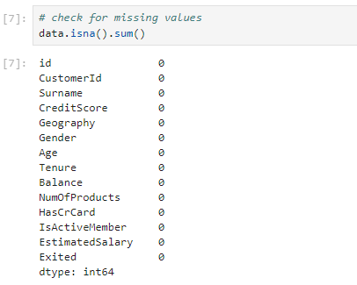

Figure Checking Missing Values

The above screen checks for missing values in the dataset.

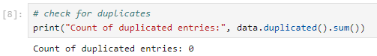

Figure Check for Duplicates

The screen checks for duplicates and encounters 0 entries.

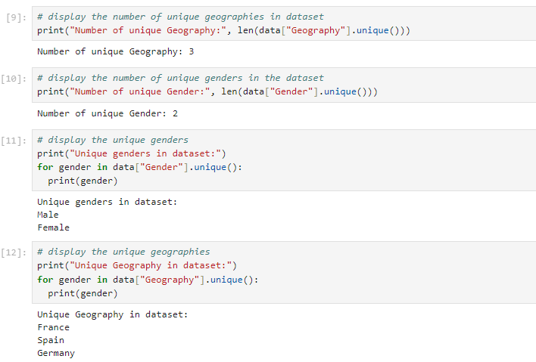

Figure Geographies in Dataset

The above figure displays the unique geographies in a dataset.

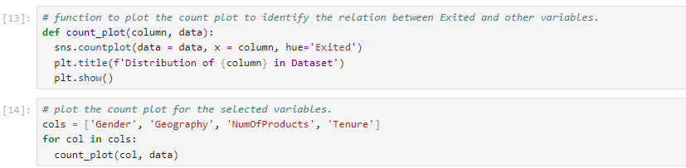

Figure Count Plot

The above screen using the matplotlib.pyplot function to plot the count plot to identify the relationship between selected variables and the variables are ‘Gender’, ‘Geography’, ‘NumOfProducts’, ‘Tenure’.

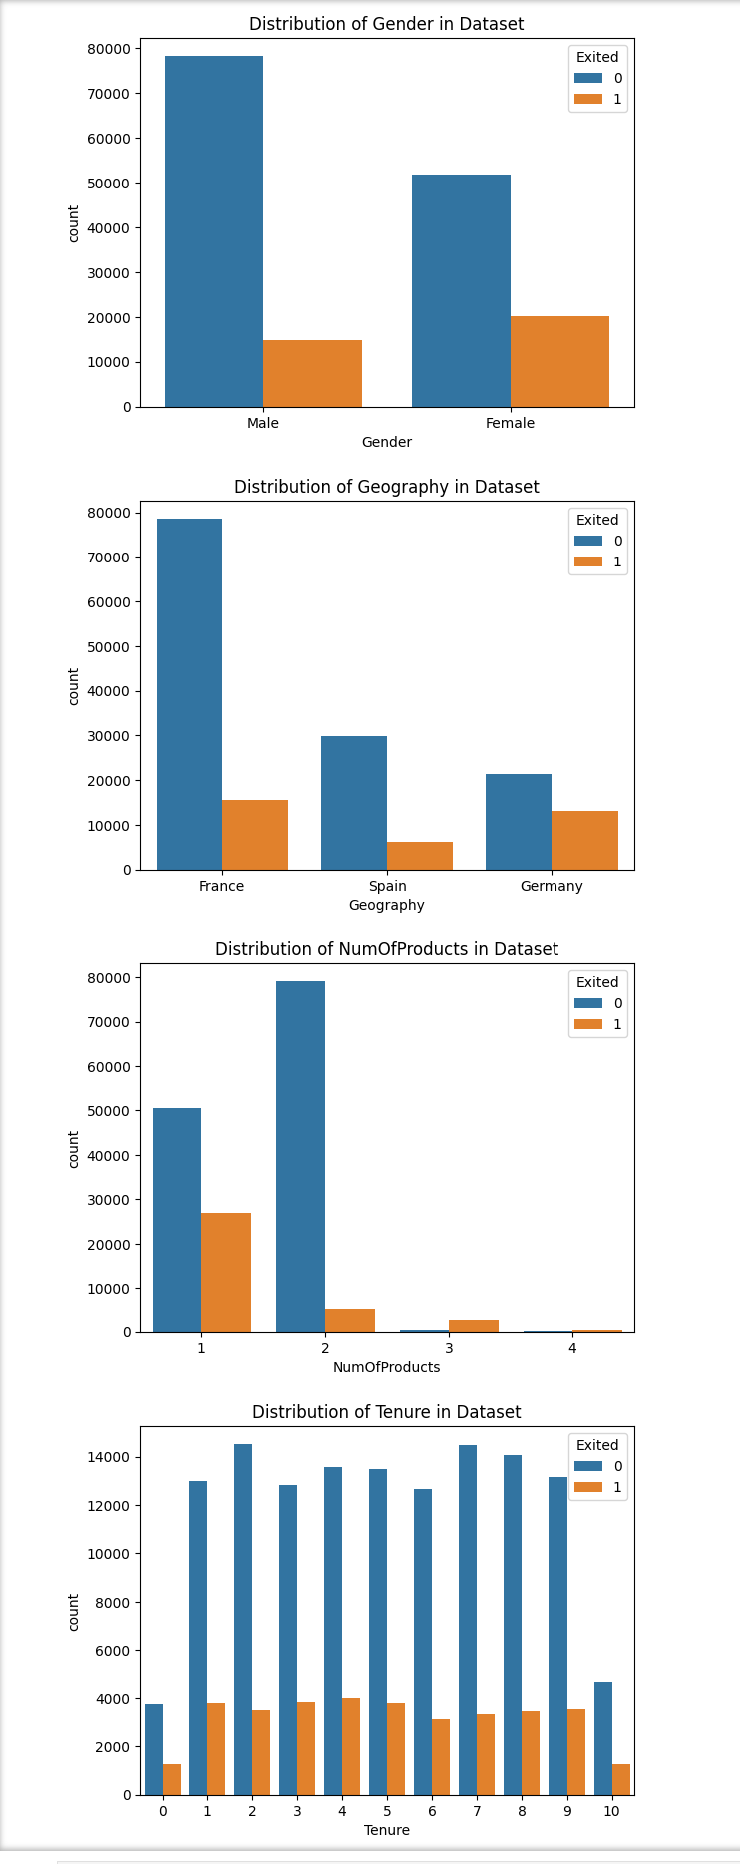

Figure Count Plot for Selected Variables

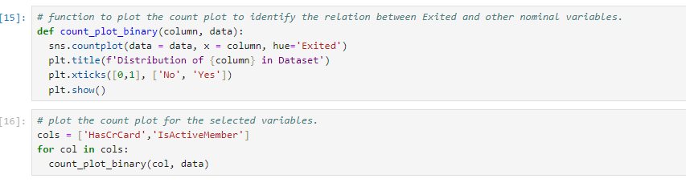

Figure Count Plot for Exited

In the screen, the identified relation between has exited and the count plot for the selected variables and the variables are ‘HasCrCard’, and ‘IsActiveMember’ .

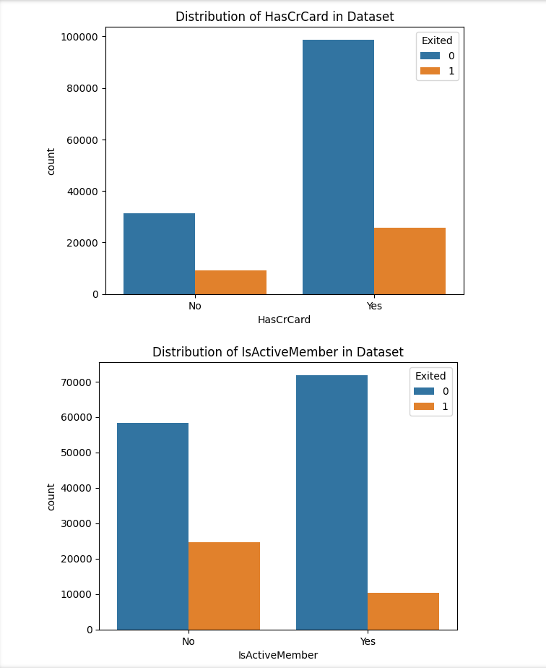

Figure Count Plot for Selected Variables

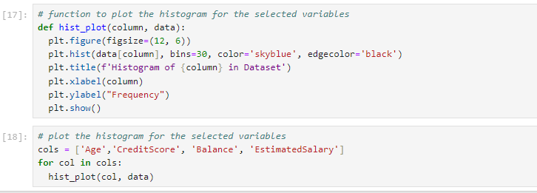

Figure Histogram Plot

The above screen, plot the histogram for the selected variables and the variables are ‘Age’, ‘CreditScore’, ‘Balance’, ‘EstimatedSalary’.

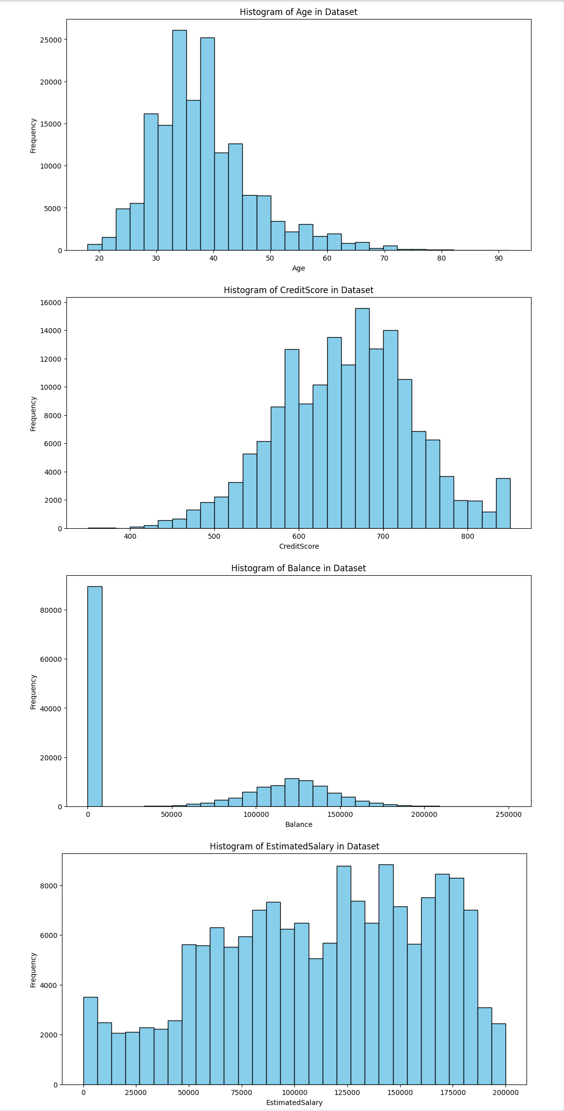

Figure Histogram Plot for Selected Variables

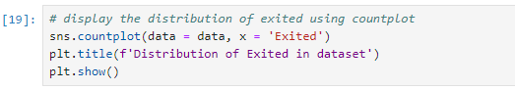

Figure Distribution of Exited in Dataset

The screen displays the distribution of exited in dataset using count plot.

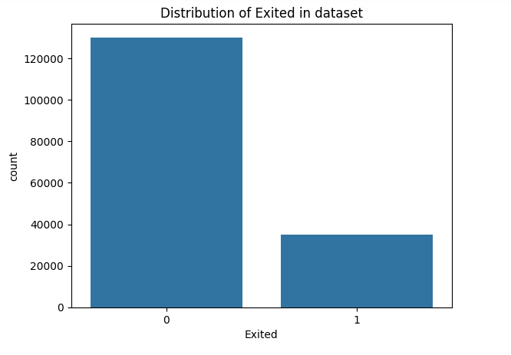

Figure Distribution of Exited in Dataset Using Count Plot

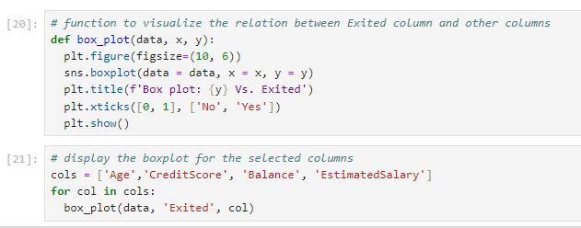

Figure Visualize Relationship between Exited Column

The above screen provides the visualize the relationship between the selected columns

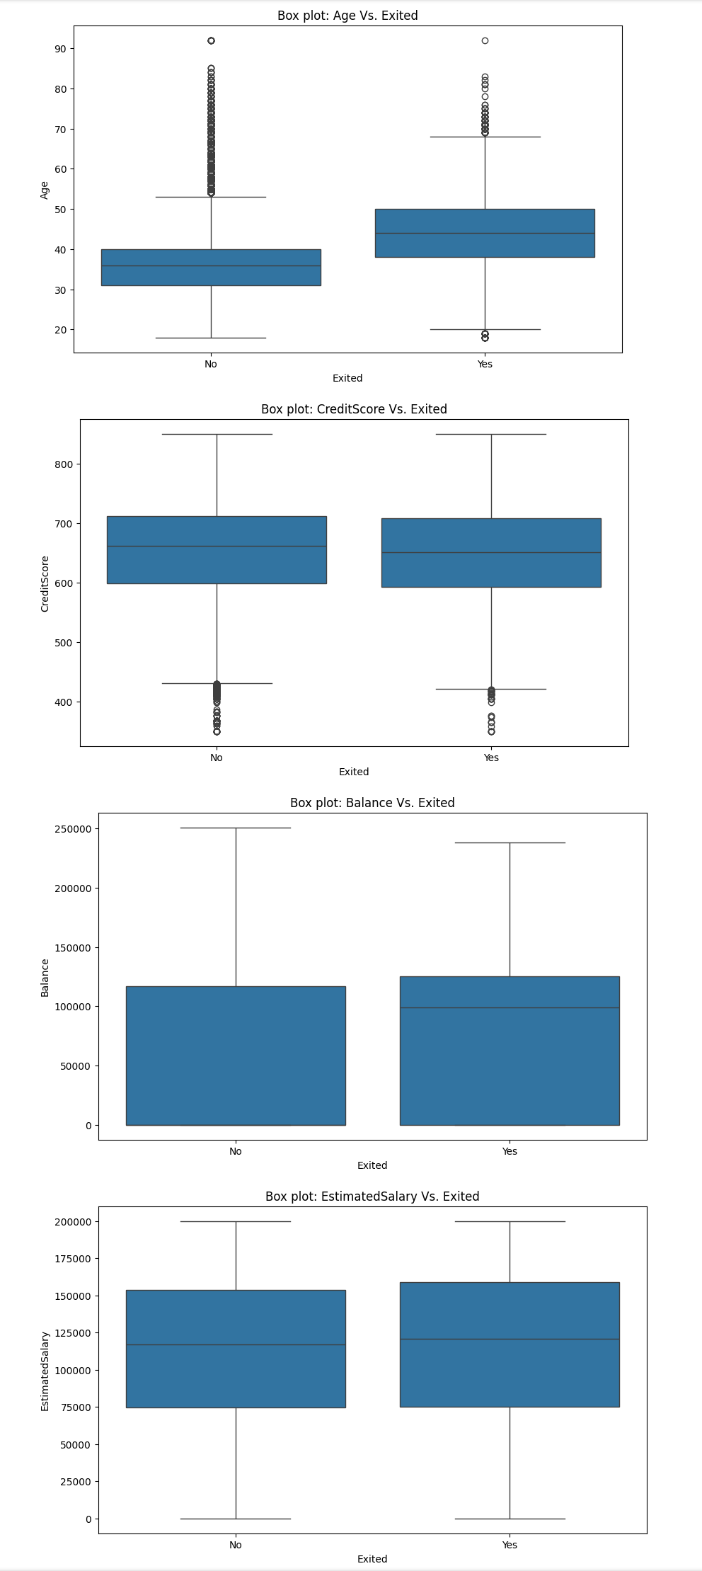

Figure Visualize Relationship between Exited Column for selected Column using Box Plot

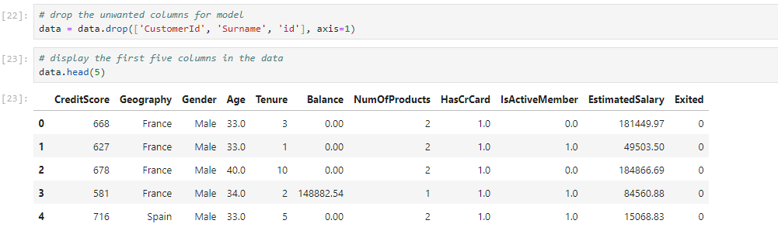

Figure Drop the Unwanted Column

In the screen, the drop function is used to drop the unwanted column for the first five columns in the data.

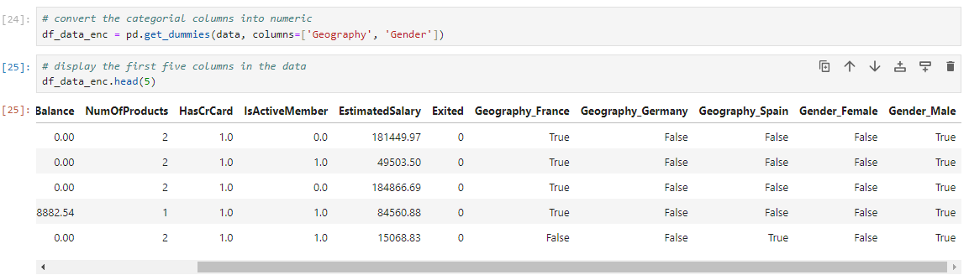

Figure Categorical Columns into Numeric Columns

The above screen, converts the categorical columns into numeric columns in the data and the columns are 'Geography', and 'Gender'.

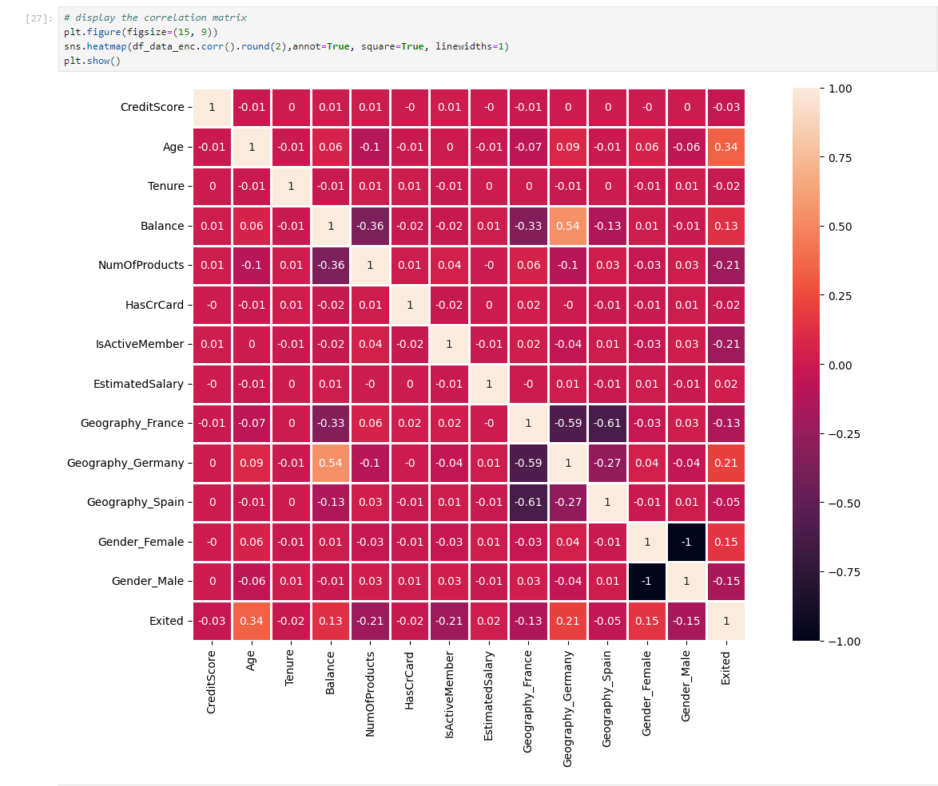

Figure Correlation Matrix

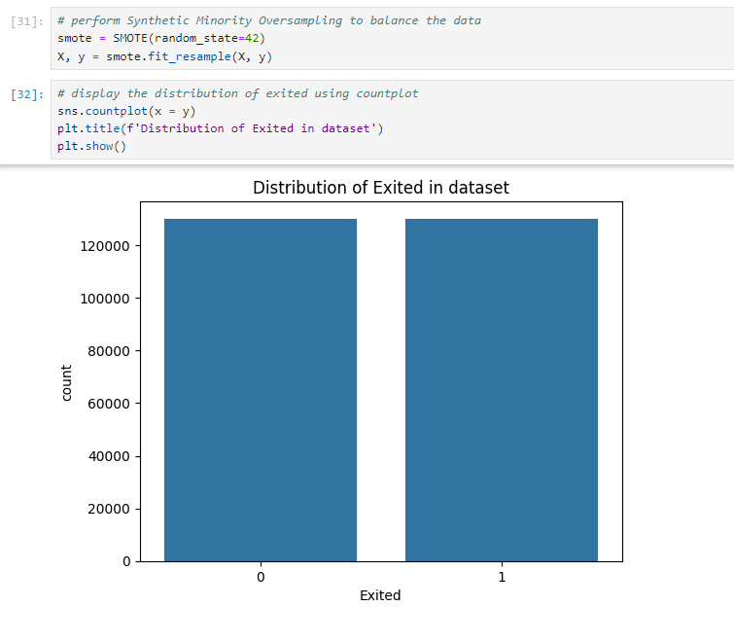

Figure Distributed of Exited in Dataset using Count Plot.

## Feature Selection and Data Splitting

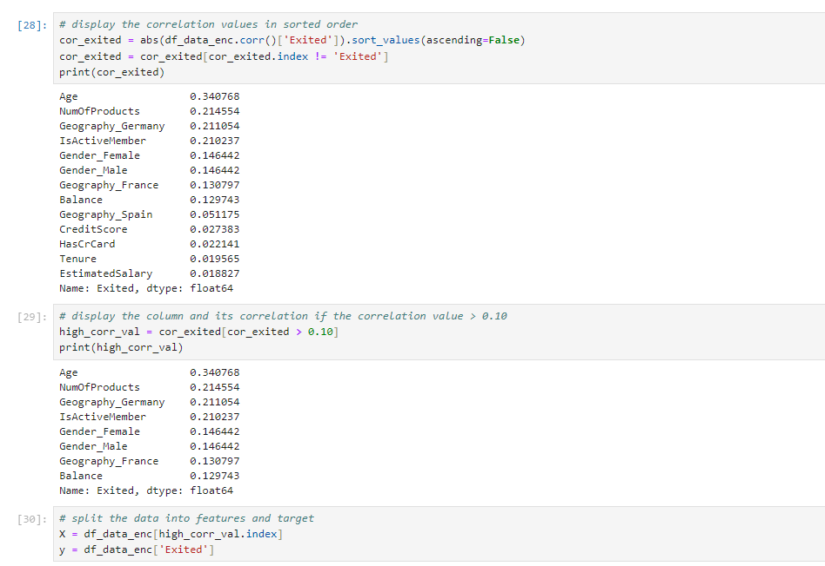

Figure Correlation Values in Sorted Order

The above screen displays the correlation values in sorted order exited, dtype is float64. The column and its correlation if the correlation value > 0.10. split the data into features and targets.

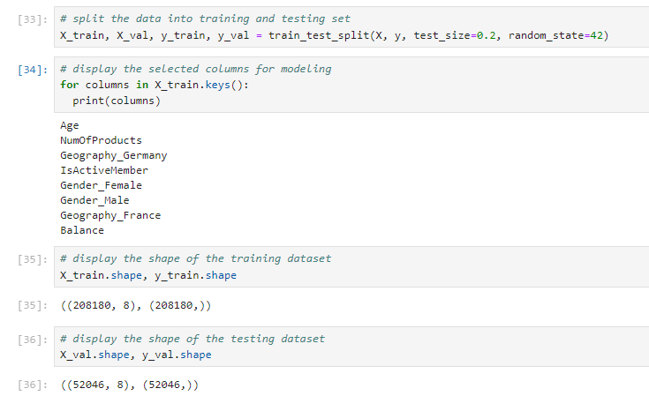

Figure Split Training Dataset & Testing Dataset

In the above screen, the dataset splits the data into training and testing sets, displays the selected training column and prints the modeling dataset. Display the shape of the training dataset with (208180 rows and testing data holds 52046 rows with 8 columns respectively.

## Machine Learning Model

During the development phase, Machine Learning algorithms were analyzed to determine the accuracy of customer churn in banking industry. Based on several analyses included with Random forest, eXtreme Gradient Boosting, Histogram-based Gradient Boosting, Gaussian Naïve Bayes, and Decision Tress. These models used for an analysis are as follows:

**Random Forest Model**

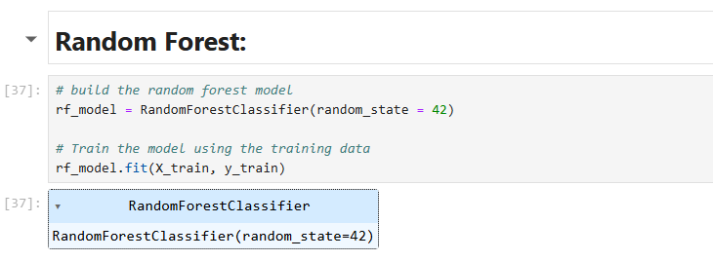

Figure Build the Random Forest Model

The random forest classifier algorithm is implemented by importing the machine learning library using Python. In the above screen, the random forest classifier model is built to train the model using the training data x_train and y_train, and the parameter random_stste=42 is used.

**Extreme Gradient Boosting Model**

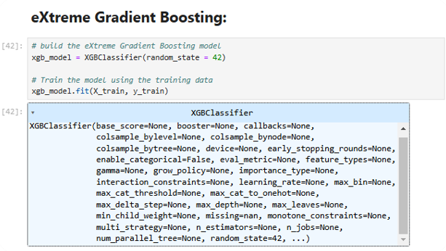

Figure Build the eXtreme Gradient Boosting Model

The eXtreme Gradient Boosting model is a machine-learning library on the above screen. This model is used to train data works with overfitting in the process of training the algorithm.

**Histogram-based Gradient Boosting Model**

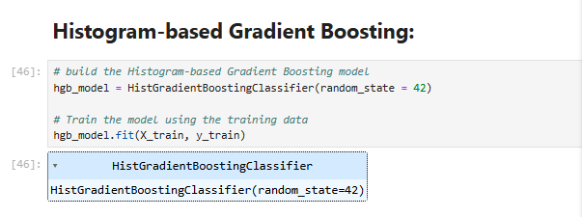

Figure Build the Histogram-based Gradient Boosting model

The above screen encounters build the Histogram-based Gradient Boosting model. This model using the training data and the fit model is used for machine learning classification.

**Gaussian Naïve Bayes Model**

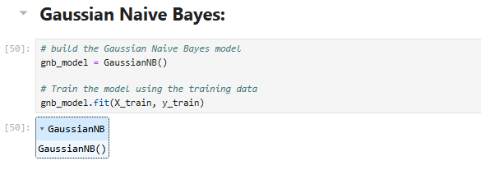

Figure Gaussian Naive Bayes

The above code is used to build the Gaussian Naive Bayes is a classification technique used in this machine-learning and the train the model using the training data using the fit model.

**Decision Tree Model**

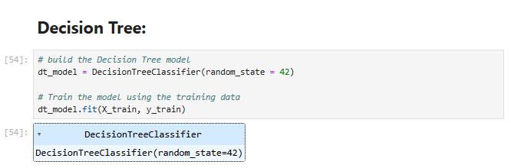

Figure Build the Decision Tree Model

The above code screen used to build the decision tree model using the fit model and train the model using the training data with random_state=42 parameter.

## Model Development

In the project for anticipating customer churn, machine models are employed. Week 12 in project implementation entails building Five machine-learning models some of which are the random forest model, extreme gradient boosting model, histogram-based gradient boosting model, Gaussian naïve Bayes model, and decision tree model.

**Random Forest Model**



Figure Random Forest Build Model

Random forest is a type of meta estimator where many decision trees are built where using the different samples and sub-samples of the initial data set the variations between these predictions are minimized to handle overfitting. This machine-learning model was selected and built in the Jupyter Notebook to train and test the model.

**Extreme Gradient Boosting Model**



Figure Extreme Gradient Boosting Build Model

XGBoost, one of the new generation the community learning algorithms improves the value of a consumption of models by training the algorithm and avoiding the difficulty of the overfitting problem. XGBoost is a supervised learning algorithm that can be explained using gradated boosting decision trees. This machine-learning model was chosen and created in the Jupyter Notebook to train and evaluate the model.

**Histogram-based Gradient Boosting Build Model**



Figure Histogram-based Gradient Boosting Build Model

Gradient boosting is another technique suite under the category of ensemble technique for constructing models in which every boosting iteration attempts to minimize the loss function introduced by the previous iteration. This type of model is used widely when carrying out both a classification and a regression task, because of their high predictive accuracy. This exported machine learning model was selected and built from the environment of Jupyter Notebook to train and test the model.

**Gaussian Naive Bayes Model**



Figure Gaussian Naïve Bayes Build Model

Gaussian Naive Bayes (GNB) is a classification technique based on a probability model that estimates probabilities, for making classifications or forecasts. This machine-learning model was chosen and created using the Jupyter Notebook with the purpose of training and evaluating the model.

**Decision Tree Model**



Figure Decision Tree Build Model

To establish a training model through which new observations can be classified or assigned a specific class or value from the target variable with a simple decision that is derived from earlier observations (training data). In Decision Trees, when it comes to predicting a class label of a record we begin at the root of the tree. This particular model was chosen and developed in the Jupyter Notebook to train and assess the model.

## Model Training and Testing

**Random Forest**

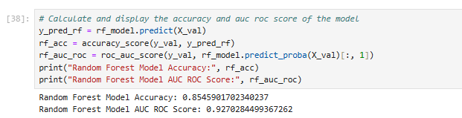

Figure Displays the accuracy of the Random Forest Model

The above screen calculates the accuracy score of 0.854 for the random forest model and the ROC score of 0.927, the model uses predict_proba to calculate by averaging the probabilities of the AUC ROC Score.

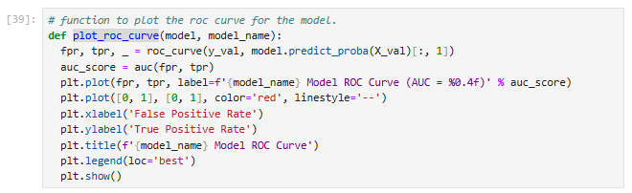

Figure Using Plot Function of Random Forest Model

The above screen using the plat function to plot the roc curve for the model is defined as the evaluation matric that plots the two different parameters as False Positive Rate and True Positive.

Rate.

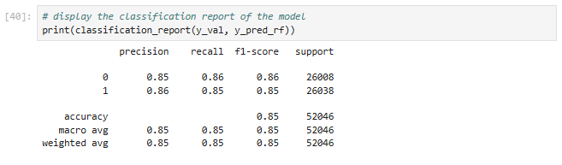

Figure Models report of Random Forest Model

The above screen provides the random forest model’s accuracy report of the precision of null, recall of null, f1-score of 0.85, and support of 52046.

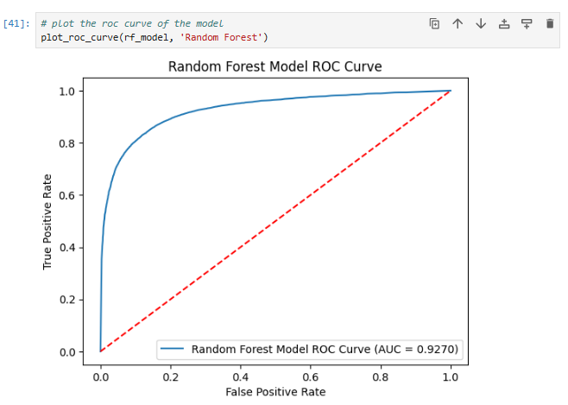

Figure ROC Curve of Random Forest Model

In the above random forest model’ the roc curve displays the true positive rate at the accuracy of 0.9270.

**Extreme Gradient Boosting Model**

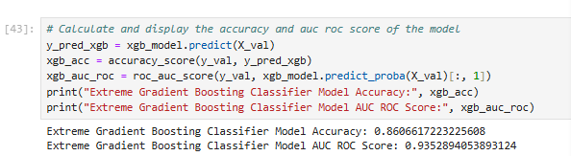

Figure Display the Extreme Gradient Boosting Model’s accuracy and roc score

The above screen displays the Extreme Gradient Boosting Classifier Model Accuracy is 0.8606 and the AUC ROC of 0.9352 Score has been calculated by the predict_proba model.

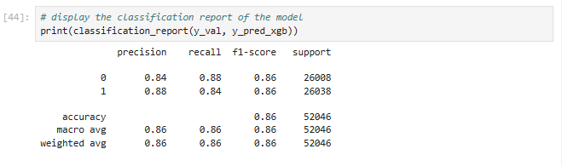

Figure Classification report of the Extreme Gradient Boosting model

The above screen displays the classification accuracy report for null precision, null recall, 0.86 of f1-score, and 52046 of support.

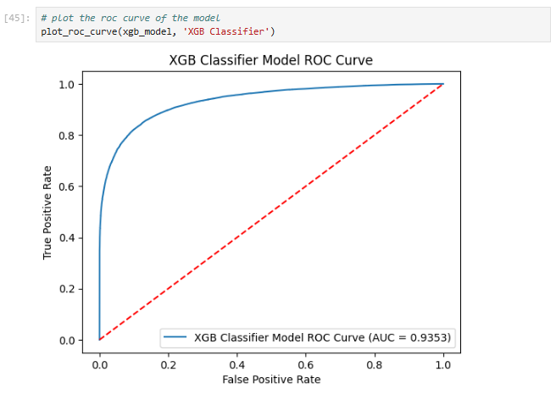

Figure XGB Classifier Model ROC Curve

The plot function is used for the roc curve of the XGB Classifier Model displays the true positive rate of 0.9353 accuracy.

**Histogram-based Gradient Boosting**

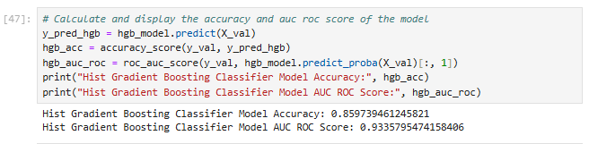

Figure Calculation of Histogram-based Gradient Boosting model’s accuracy

The above screen displays the Histogram Gradient Boosting Classifier Model Accuracy is 0.8597 and AUC ROC of 0.9335 Score by the predict_proba model.

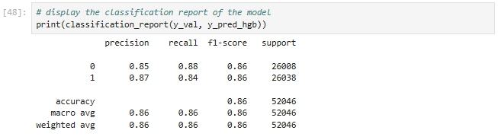

Figure Classification report of the Histogram Gradient Boosting Classifier Model

The above screen displays the classification accuracy report of the model of null precision, null recall,0.86 of f1-score, and 52046 of support.

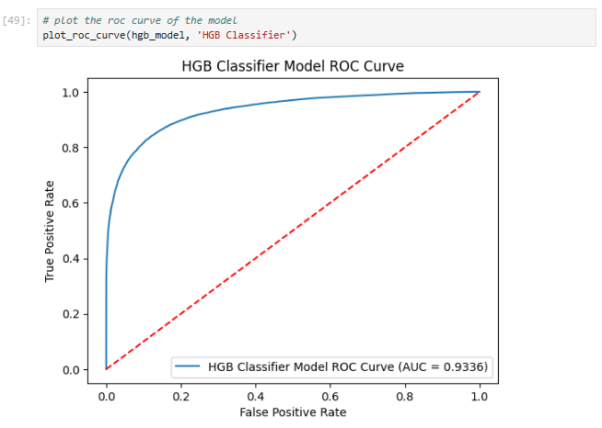

Figure Histogram Gradient Boosting Classifier Model ROC Curve

The above screen encounters the plot function used to display the HGB Classifier Model ROC Curve of true positive rate at 0.9336 accuracy.

**Gaussian Naive Bayes**

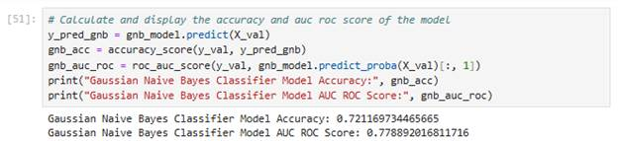

Figure 40 Calculate the Gaussian Naïve Bayes model’s accuracy

The above screen is used to calculate and display the Gaussian Naive Bayes Classifier Model Accuracy is 0.7211 and AUC ROC of 0.7788 Score by using the predict_proba model.

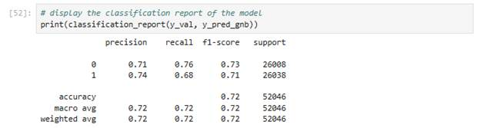

Figure 41Classification report of the Gaussian Naive Bayes Classifier Model

The above screen displays the classification accuracy report of null precision, null recall, 0.72 of f1-score, and 52046 of support.

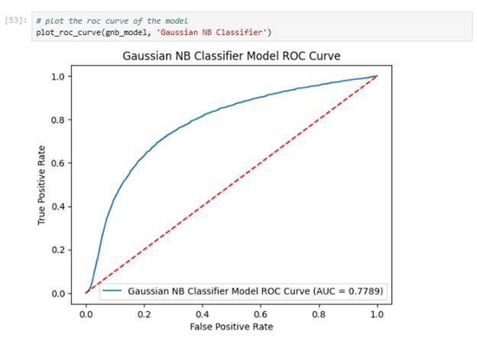

Figure 42Gaussian Naive Bayes classifier Model Roc Curve

The plot function used to display the ROC Curve of the Gaussian NB Classifier true positive rate of accuracy is 0.7789.

**Decision Tree**

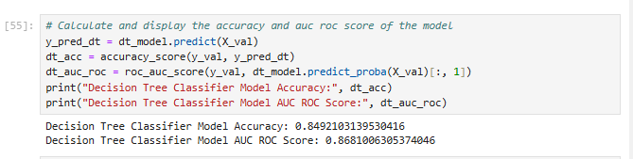

Figure Displays the Decision Tree Model’s accuracy

The above screen provides the calculation of the Decision Tree Classifier Model Accuracy is 0.8491 and the AUC ROC of 0.8681 Score is calculated by using the predict_proba model.

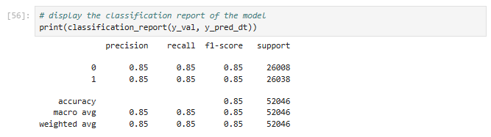

Figure Classification report of the Decision Tree Classifier Model

The above screen provides the classification accuracy report of the null precision, null recall, 0.85 of f1-score, and 52046 of support.

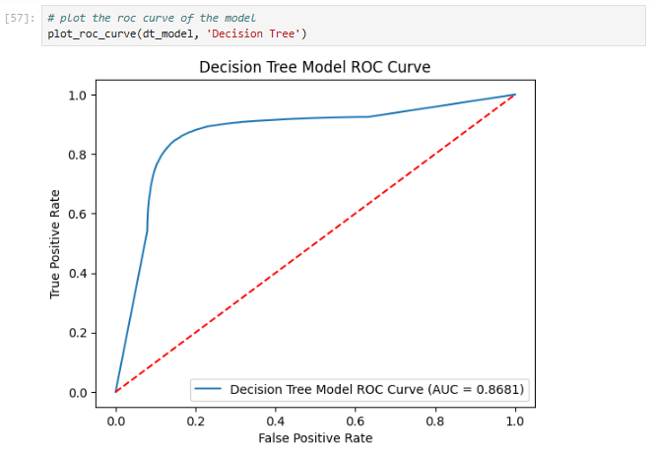

Figure Decision Tree Model ROC Curve

The Plot function is used in this screen to provide the ROC Curve of the Decision Tree Model’s true positive accuracy rate is 0.8681.

**Front End Design**

The web pages for dynamic churn prediction have been developed by HTML, CSS, JavaScript, and Flask.

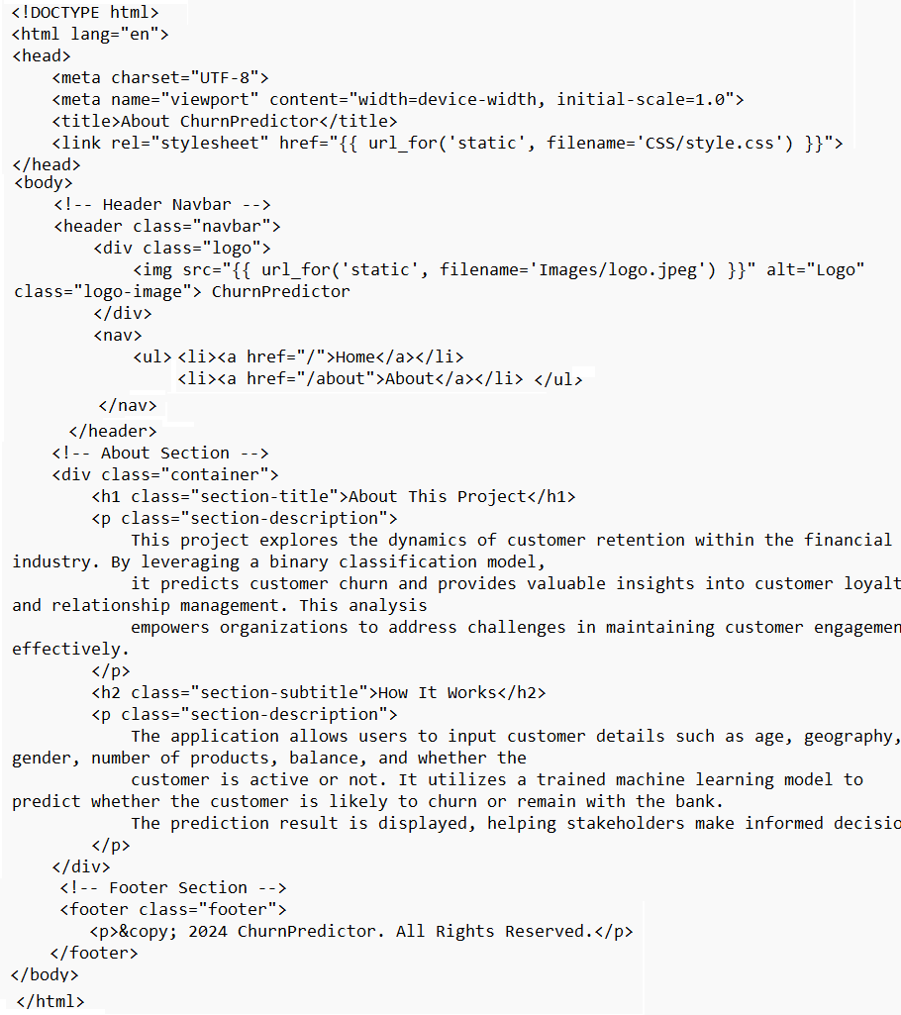

Figure : Code for the About Page of the website

The above page of the churn predictor website is developed by using html and css technologies. The head functions are used to describe the heading of the About page, and the title is used to describe the specific title “About ChurnPredictor”. Using CSS style, the logo and other features are integrated with the website. Using a paragraph, the context of how the project will work and how it can be utilized are provided in the program.

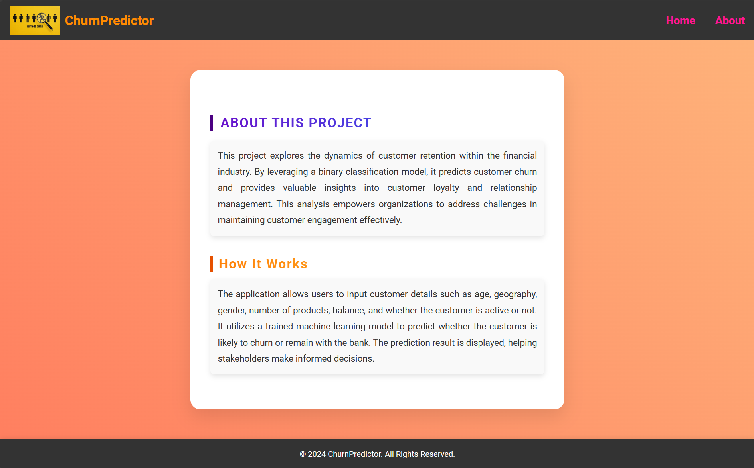

Figure : Outcome of about webpage

The page is created with logo and menu components and the context is displayed in the center of the webpage. There would be a two context, one is about this project and another is hot it works. It helps to understand the process of the developed churn predictor web application.

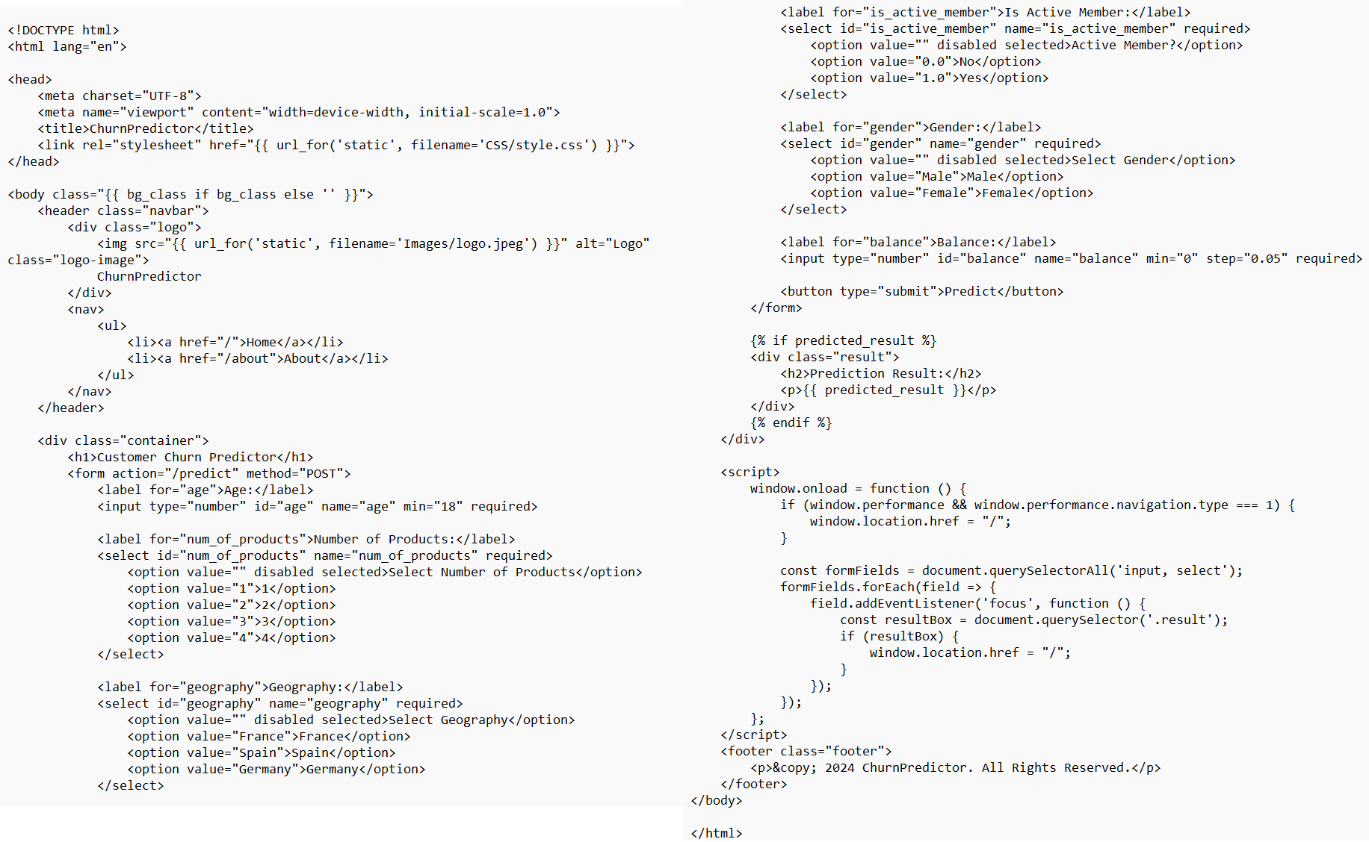

Figure : Code for the Home Page of the Website

The above code provides home page content with class, form, and script. It initiated with title and style using the CSS class file “style.css” within the container, a form for predicting the churn is created with multiple labels, options, and labels. Age and balance variables are validated from the input. Within the script block, a JavaScript program is used to create the windows.onload function that navigates the page transfers the customer data to the backend and lists the value once it has been evaluated.

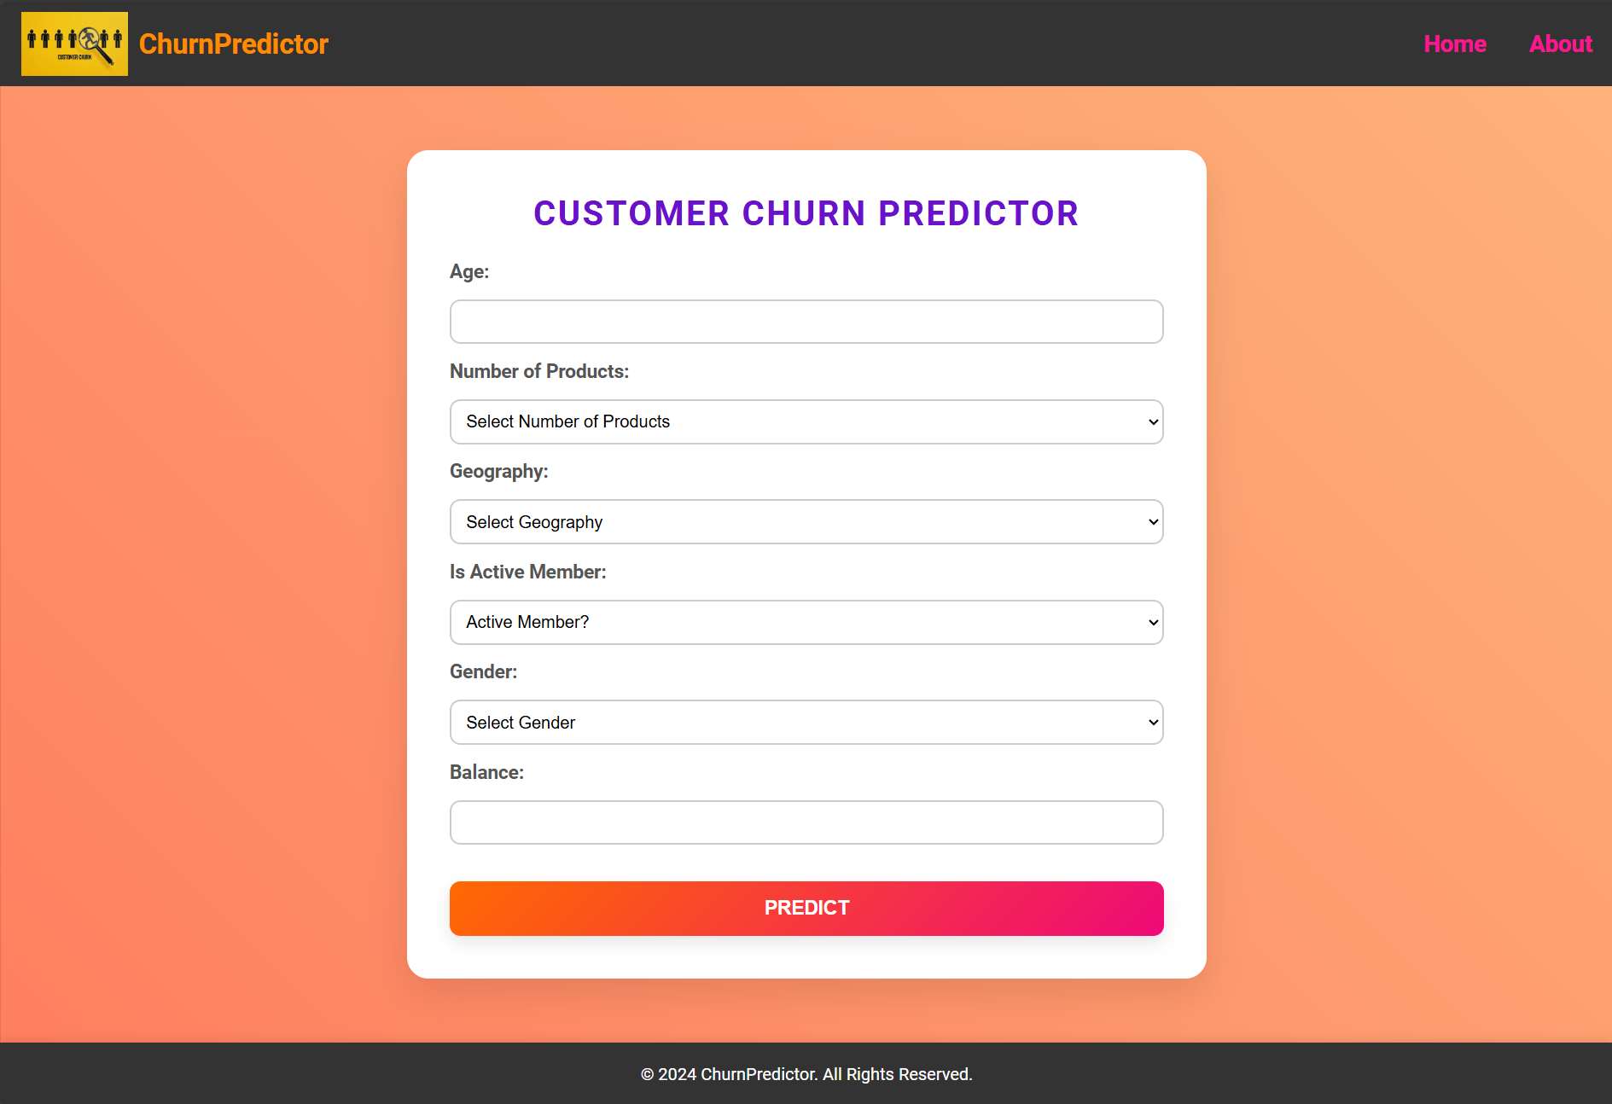

Figure : Customer Churn predictor home page

The home page is generated with multiple components within the predictor form. It is associated with labels, text inputs, selection boxes, and submit buttons. The web page allows the user to enter the input in text input blocks and perform the prediction by the predict button.

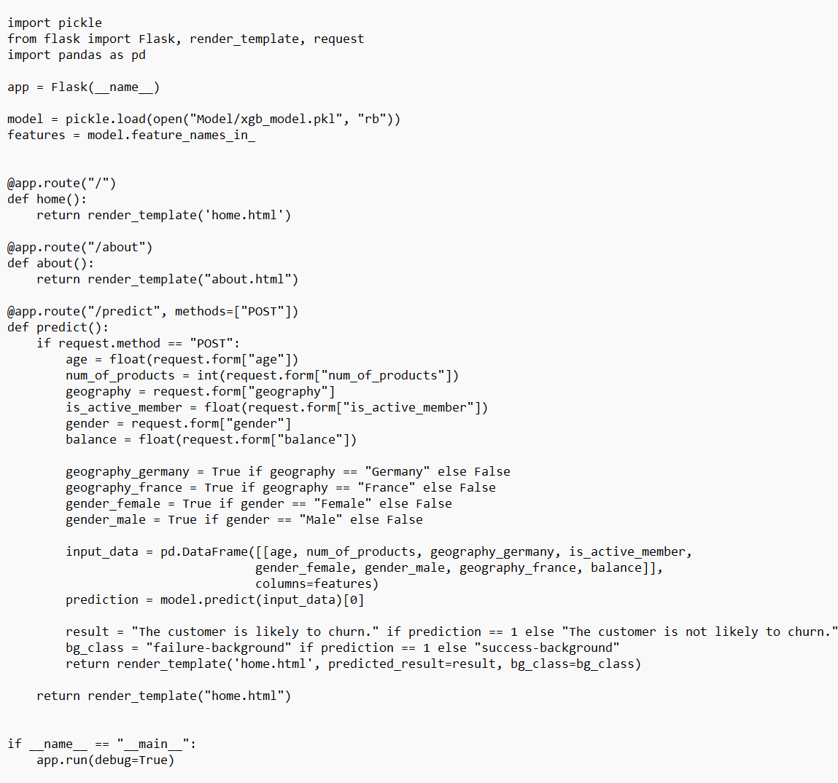

Figure : Backend code with Flask

The above program provides a flask-based web application that has been designed to predict customer churn using a trained XGBoost model. It provides a simple user interface to provide customer details as input and receive the result of prediction on customer data whether the customer is likely to leave the bank or not. The pickle is used to load the trained model, the Flash case is used to set up the website, and pandas are used to structure the input. The model can be loaded into the program by picke.load, and the developed HTML pages, such as home, about, and prediction route functions, are integrated with the program. Feature encoding has been performed in the code on geography and gender data, and the backend has been connected with pandas to describe the user input into frames.

# Chapter V: Testing Process

## Model Testing

The document presents a sequential procedure of elaborating and verifying the predictive model for its efficiency, robustness, and applicability, they are the procedures that were followed in below.

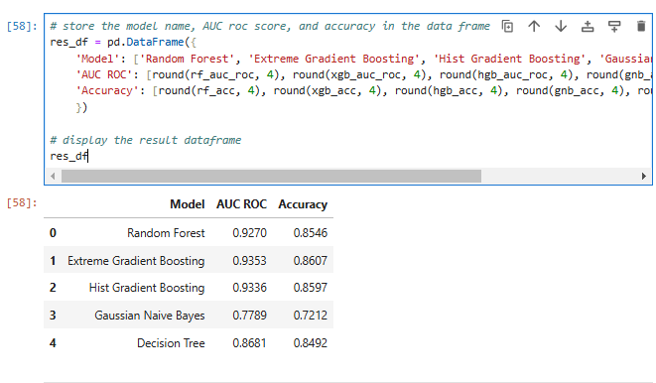

Figure Displays the Data frame

The above code screen stores the Model name, AUC ROC Score, and Accuracy in the data frame displayed in the results.

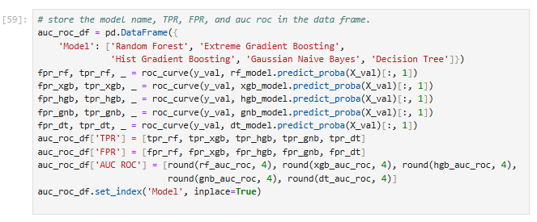

Figure All Models under Single Data Frame

In the above screen, store the model name, TPR, FPR, and AUC ROC in the data frame.

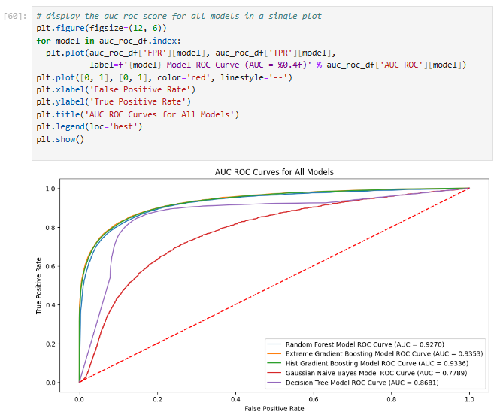

Figure : AUC ROC Curve for All Models

The above screen displays the AUC ROC score for all models in a single, the plot function is used to display the AUCROC accuracy for all models in a single plot.

## Website Testing

The website is tested using manual testing, and the functionalities of the webpage are evaluated by usability testing. The below table provides test cases and the results of test cases (Evidences in Appendix).

Table : Test case for the website

|  |  |  |  |  |  |
| --- | --- | --- | --- | --- | --- |
| **Test ID** | **Test case description** | **Steps** | **Expected output** | **Actual output** | **Results** |
| #1 | Home page | 1. Click on the home button | Home page with churn prediction form | Home page with churn prediction form | Pass |
| #2 | About page | 1. Click on the About button | Navigated to the About page | Navigated to the About page | Pass |
| #3 | Age validation | 1. Click on the home button 2. Enter 15 in the age input box | Value must be greater than or equal to 18 | Value must be greater than or equal to 18 | Pass |
| #4 | Balance validation | 1. Click on the home button 2. Enter age “30” 3. Select the number of products “2” 4. Select geography “Germany” 5. Select Is active member “Yes” 6. Select gender “female” 7. Enter balance “-2000” | Value must be greater than or equal to 0 | Value must be greater than or equal to 0 | Pass |
| #5 | Valid inputs | 1. Click on the home button 2. Enter age “30” 3. Select the number of products “2” 4. Select geography “Germany” 5. Select Is active member “Yes” 6. Select the gender “female” 7. Enter balance “12000.30” 8. Click on “Predict” | Prediction Results: The customer is not likely to churn | Prediction Results: The customer is not likely to churn | Pass |

# CHAPTER VI: RESULTS

**Predictive Model Performance Results**

Based on the analysis of customer churn in the banking industry to classify the retention strategy, different machine-learning modes were developed. Each machine learning model has precision, recall, f1-score, and support which are possessed in customer churn in the banking industry. The ROC AUC (Receiver Operating Characteristic Area Under the Curve) Curves for all models, below screen shows the comparison of accuracy values for different models.

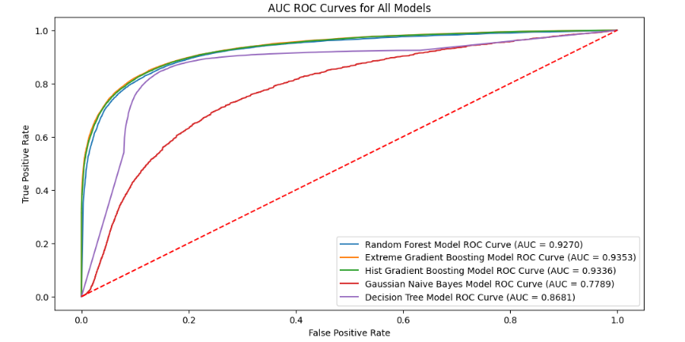

Figure Accuracy of Machine Learning Model

According to the above Curves, the Extreme Gradient Boosting Model, Histogram Gradient Boosting Model, and Random Forest Model have parallel and highest accuracy values of 0.9336, 0.9353, and 0.9270. whereas the Decision Tree Model has a significant prediction and classification as predicting the probability of retention strategy with an accuracy of 0.8681. When compared to all other machine learning models the Gaussian Naïve Bayes Model has the lowest accuracy of 0.7789 in predicting retention strategy.

**Website Results:**

Using manual testing customer churn predictor website has been tested and the results are captured.

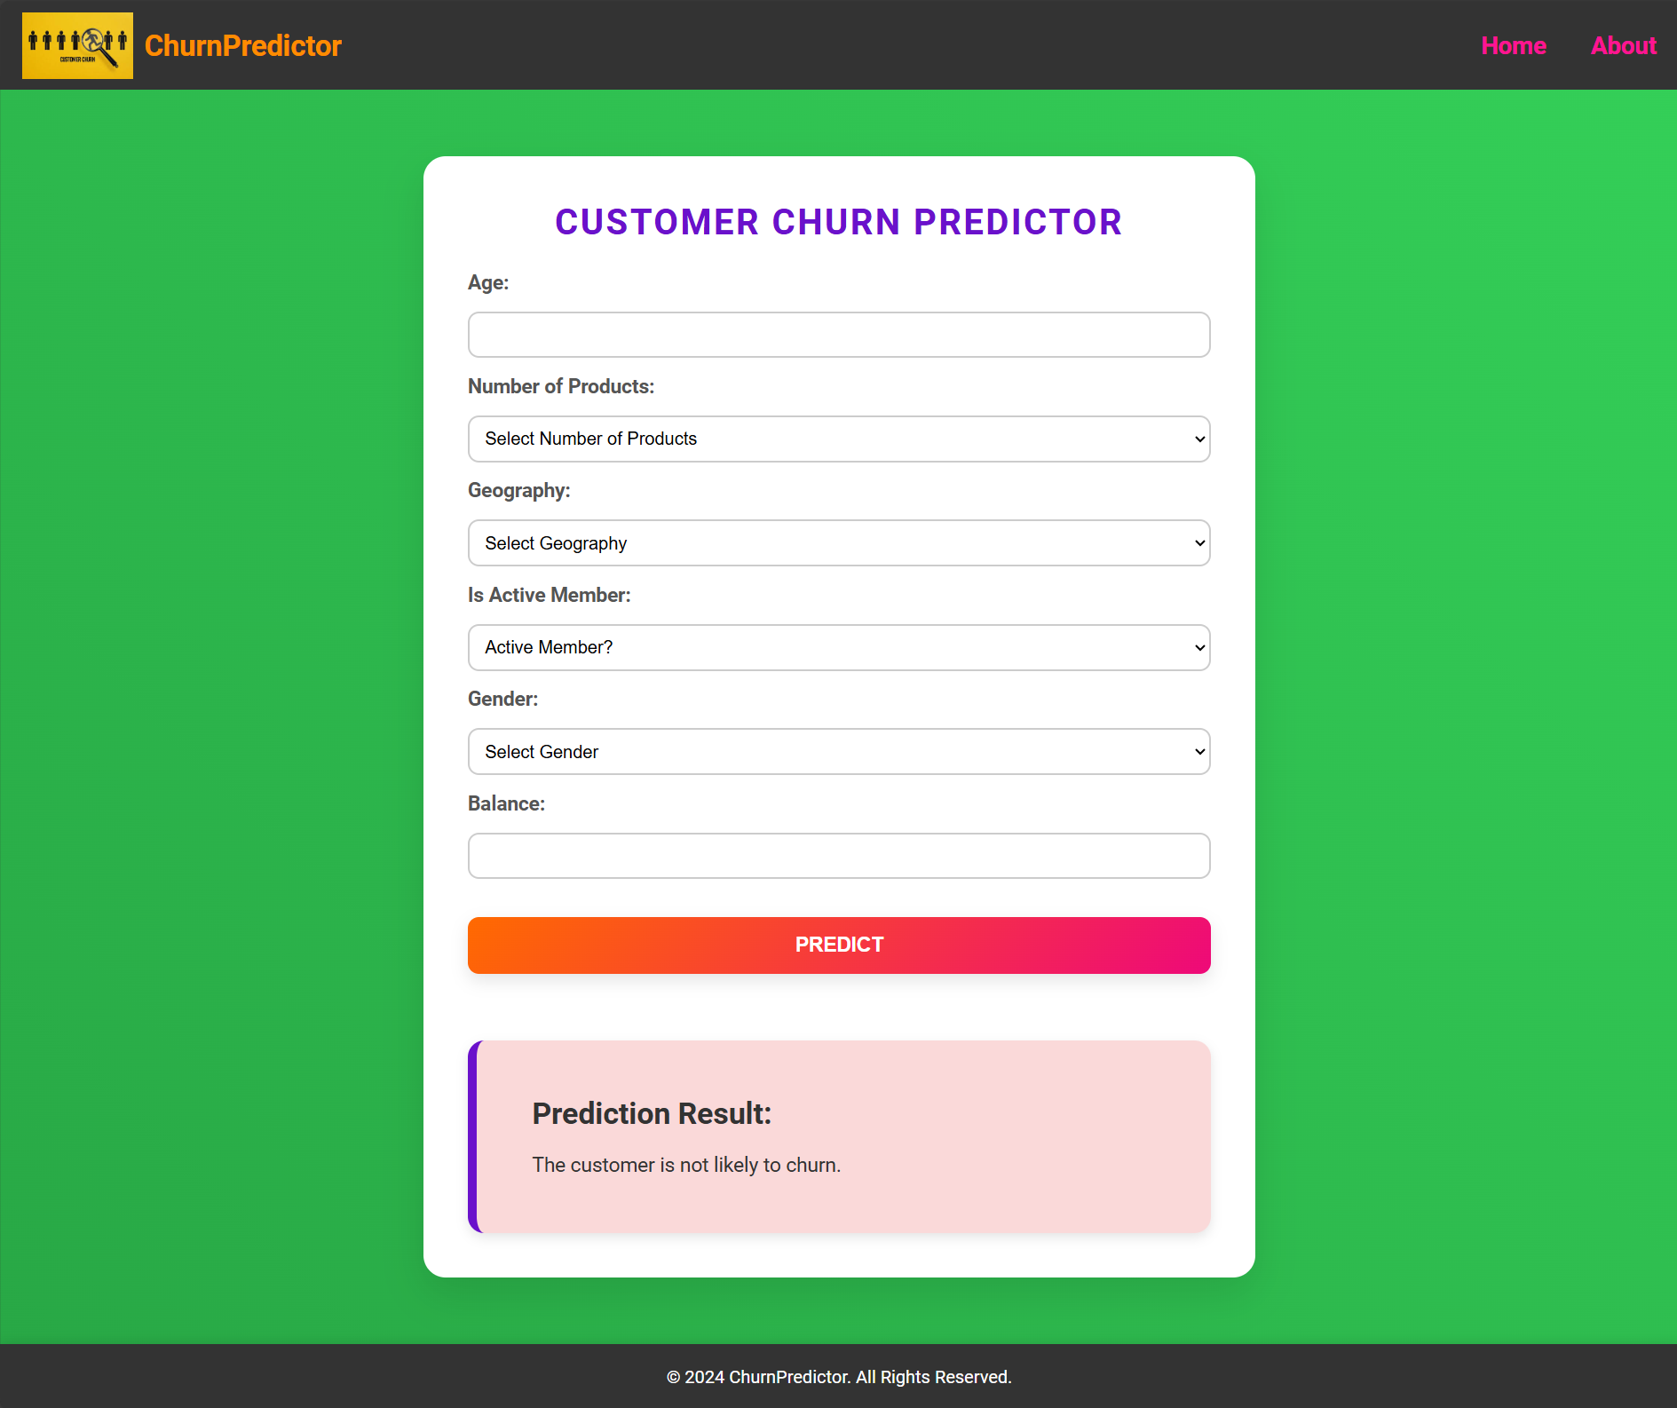

Figure : Result 1 for prediction

The above screen provides Positive results of customer churn prediction. When the user provides all the inputs with valid entries and submits the form, the web application provides the result as “Prediction Result: The customer is not likely to churn”.

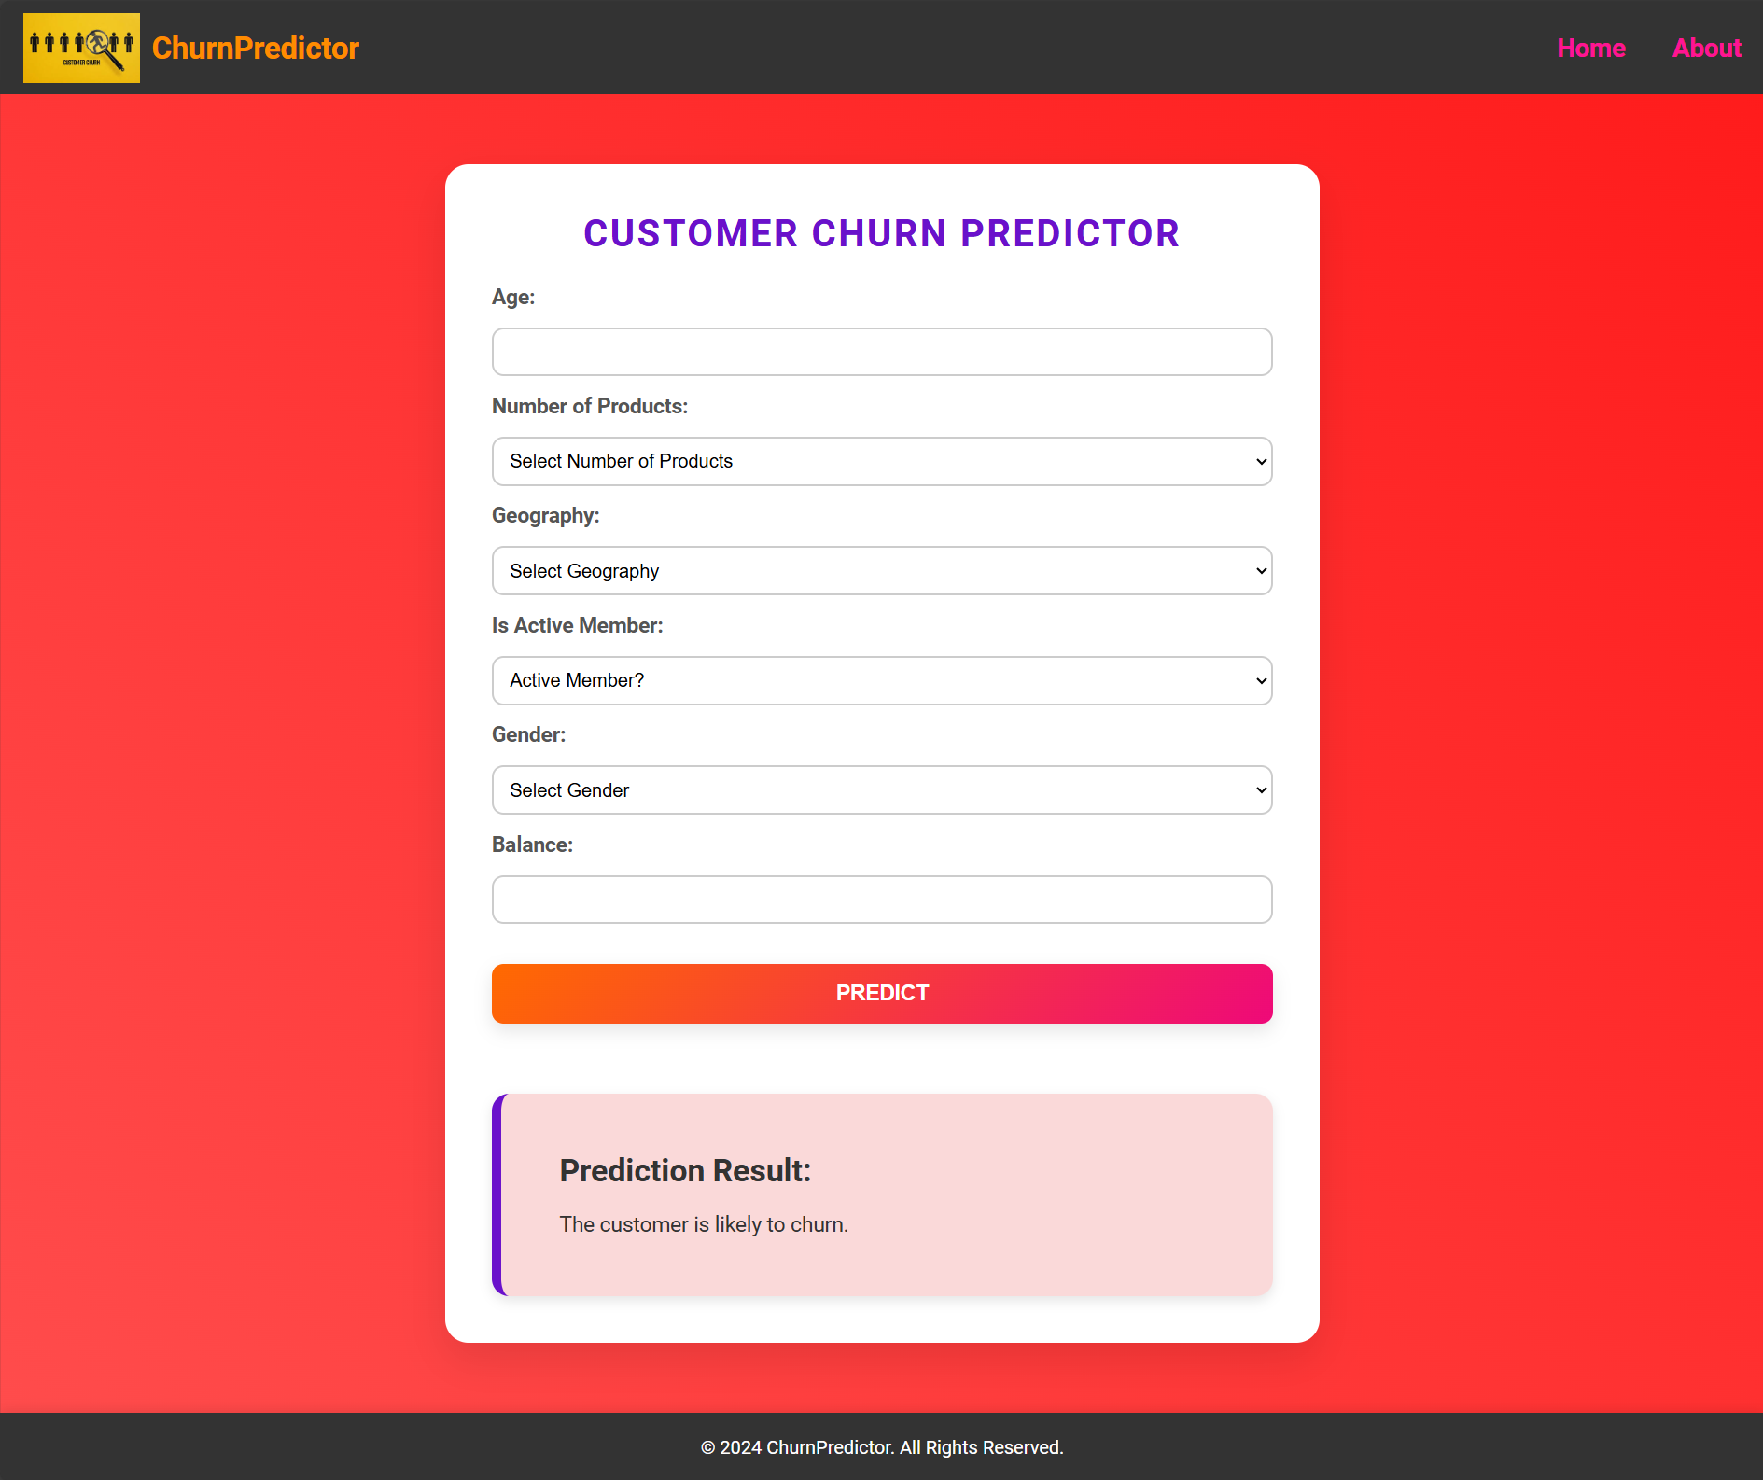

Figure : Result 2 for prediction

When entering the user input with valid entries, the web application transferred the input to the prediction model and displayed the answer “Prediction Result: The customer is likely to churn.”

# CHAPTER VI: Ethical Issues

## Ethical issues and considerations

Ethical factors play a crucial role in developing predictive models. The models sometimes do not follow ethical values and as a result, it would cause biases in the historical data which is very important to make important decisions [14]. And this bias might result in unfair results and that indeed leads to poor decisions. Machine learning algorithms need to consider ethics to avoid bias and unfair values. During the predictive model-building process, the data must be collected from banks that include sensitive information about customers such as account numbers, transaction history, interactions, and so on. So, the banks must be transparent in the predictive processes and during the disclosure of factors needed for the prediction of customer churn. Banks are responsible for protecting their customer privacy and they must obtain explicit consent for using the customer data which would avoid legal and ethical issues. In addition to this, the banking sector must also follow GDPR to ensure the data is safe and secure [10]. The Web application necessitates security and privacy due to the application associated with customer data, including sensitive information such as account balance. Data encryption would be significant to protect the information from unauthorized access and cybersecurity attacks [15].

## Issues addressed

* It is essential to follow ethical values which is very much important to maintain customer trust. Banks must take additional measures to protect their data from unauthorized access and security breaches thereby building a robust security framework.
* To avoid bias, certain techniques related to bias detection have to be implemented. Hence by addressing the ethical issues, banks could effectively build a model for predicting customer churn and make effective decisions.
* The Web application features should explain the data that is being collected and processed from the customer which helps to build trust and accountability.

# Chapter XIII: Business Concerns and Needs

## Business concerns and budget constraints

Business concerns and budget constraints for predictive models for anticipating customer churn in the banking industry in developing predictive models for anticipating customer churn in the banking industry. There are several business concerns and budget constraints are addressed as clear project objectives, well-defined project scope, efficient resource allocation, utilization of open source solutions, and iterative development approach. By addressing these business concerns and budget constraints, the development of websites and predictive models for customer churn in the banking industry can be conducted efficiently and effectively. Ensuring that the customer churn project meets its goals while remaining within budget.

* The aim of the project at the initial stage is to reduce costs when allocating resources and the churn prediction model as an impact on customer retention strategies.
* The project scope includes the size of the dataset, user-friendly website interface, and the machine learning techniques to be used for analysis and ensures efficient resource allocation is expected for outcomes.
* Resource allocation effectively throughout the development process helps to reduce the workload is ensuring that the projects stay within budget to focus on refining the dynamic website and model accuracy improvement.
* Iterative development approach mitigates budget constraints by addressing and ensuring that the project is aligned with project goals and enhances the web application performance by continuously improving and dynamic prediction based on real-world data.

## Learning outcomes

**Recognizing Business Challenges**

The initiative focuses on the way that customer churn impacts the growth and revenues of a bank. Understanding that customer attrition is a big issue has made it possible to design anticipative retention strategies that would help retain the clients and their earnings consistently. The website integration allows the bank staff to predict the churn risk of their customers in real-time and provides immediate insight.

**Strategic Resource Allocation**

Decision support, based on the integration of predictive models into banking production processes, offers data on the ways of optimizing resource usage. Loyalty plans, and incentives are specifically appropriate for curbing attrition since other studies used tailored approaches. The website aids in dynamic churn prediction and helps make responsive strategies for specific customer based on their behavior.

**Cost-Benefit Analysis**

Understanding how budget goals for finances as well as budget constraints affect the processes of using machine learning solutions provides a good view of how to balance financial health and financial risks with technological advancement. In web application development initial cost has been introduced with long-term benefits like improving customer retention and enhancing targeted strategies.

**Improving Stakeholder Collaboration**

The more effective adaptation of predictive analytics for more precise campaigns and improved customer contact entails interdepartmental collaboration within a business. Communication between different departments in the bank can be issued with the unified platform of customer churn web application for data accessing and decision making.

**Data-Driven Decision Making**

The chapter relates to the role of data analytics in the achievement of specific patterns and trends, in this case enabling banks to make the right decisions toward their mandates. A real time inputs can be processed through the web application which helps to enhance data-driven decision-making by up to date.

# CHAPTER IX: CONCLUSION

Predictive models for anticipating customer churn in the banking industry used significant potential to enhance customer retention strategies. By leveraging advanced machine learning techniques for banks, banks can proactively identify customers at risk of churning and implement targeted interventions to retain existing customers. The findings underscore the effectiveness of models such as Random forest, eXtreme Gradient Boosting, Histogram-based Gradient Boosting, Gaussian Naïve Bayes, and Decision Trees. These models accurately predict churn based on various customer types and the behavior of their transaction data. These models facilitate personalized marketing efforts and can improve customer satisfaction. Web application development and predictive model integration enhance the real-time data collection ability. It helps to predict the customer data in a real-time environment and provides immediate churn results. The website is designed with user-friendly attributes, and the platform ensures predictions with a deeper understanding of customer behavior. To overcome customer churn optimizing resource allocation is the ultimate recommendation for leading to a higher customer retention rate and increased bank profitability. However, challenges such as data quality, privacy concerns, and the need for continuous model refinement must be addressed to fully harness the benefits of predictive analytics in the banking sector. This predictive model with a web application for anticipating customer churn in the banking industry has continued research and innovation in this banking sector that will enable banks to stay competitive and meet evolving customer needs effectively. The web-based application was developed to predict the customer churn in the banking industry, by applying machine learning techniques to provide strategies to retain the Data Pre-Processing on this milestone report on this development process. The ongoing research of developed web publications will enable the banks to adopt and evolve the customer requirements effectively and ensure long-term success.

# REFERENCES

|  |  |
| --- | --- |
| [1] | A. Muneer, R. F. Ali, A. Alghamdi, S. M. Taib, A. Almaghthawi and E. A. A. Ghaleb, "Predicting customers churning in banking industry: A machine learning approach," *Indonesian Journal of Electrical Engineering and Computer Science,* pp. 539-549, 2022. |
| [2] | H. Tran, N. Le and V.-H. Nguyen, "Customer churn prediction in the banking sector using machine learning-based classification models," *Interdisciplinary Journal of Information, Knowledge, and Management,* vol. 18, pp. 87 - 105, 2023. |
| [3] | P. Boozary, S. Sheykhan and H. GhorbanTanhaei, "Bank Customer Churn Prediction Using Various Machine Learning Algorithms," *Journal of Management Information and Decision Sciences,* vol. 27, no. 03, pp. 01-18, 2024. |
| [4] | M. Bogaert and L. Delaere, "Ensemble Methods in Customer Churn Prediction: A Comparative Analysis of the State-of-the-Art," *Jpurnal of Mathematics in MDPI,* vol. 11, no. 24, pp. 01-28, 2023. |
| [5] | S. Zhao, "Customer Churn Prediction Based on the Decision Tree and Random Forest Model," *Journal of BCP Business & Management,* vol. 44, pp. 339-344, 2023. |
| [6] | K. NISHITHA and M. JALAJAKSHI, "BANK CUSTOMER CHURN PREDICTION USING MACHINE LEARNING TECHNIQUES," *Journal of Engineering Sciences,* vol. 15, no. 08, pp. 576-582, 2024. |
| [7] | K. Asif, K. Anas and S. Sankhe, " Dynamic Customer Churn Prediction Using Machine Learning Algorithm," *International Journal of Creative Research Thoughts,* vol. 12, no. 4, pp. 511-521, 2024. |
| [8] | V. Vignesh and S. Babu, "CUSTOMER CHURN PREDICTION & ANALYSIS," *International Research Journal of Modernization in Engineering Technology and Science ,* vol. 06, no. 05, pp. 10722-10727, 2024. |
| [9] | S. Sharma, A. kumar, B. Kumar and Imaduddin, "CHURN PREDICTION USING MACHINE LEARNING IN BANKING SECTOR," *International Journal Of Progressive Research In Engineering Management And Science,* vol. 4, no. 5, pp. 1683-1687, 2024. |
| [10] | P. Chiurunge, A. Kandiero and S. Chizwina, Customer Churn Prediction for Financial Institutions Using Deep Learning Artifcial Neural Networks in Zimbabwe, Zimbabwe: Theoretical and Conceptual Frameworks in ICT Research, 2023. |
| [11] | S. Zhao, "Customer Churn Prediction Based on the Decision Tree and Random Forest Model," *Journal of BCP Business & Management ,* pp. 339-344, 2023. |
| [12] | A. Manzoor, M. A. Qureshi, E. Kidney and L. Longo, "A Review on Machine Learning Methods for Customer Churn Prediction and Recommendations for Business Practitioners," *Journal of IEEE Access,* pp. 01-34, 2023. |
| [13] | M. J. Mohona, "Emerging cyber security threats in banking sector; Loopholes and solutions in the eye of law," *International Journal of Law,* vol. 10, no. 3, pp. 214-219, 2024. |
| [14] | Y. Suh, "Machine learning based customer churn prediction in home appliance rental business," *Journal of Big Data,* p. 01 of 35, 2023. |
| [15] | S. Disawal and U. Suman, "Enhancing Security to Prevent Vulnerabilities in Web Applications," *International Journal of Engineering Trends and Technology,* vol. 72, no. 7, pp. 278-283, 2024. |

# Appendix A

## Project Pan and Launch Checklist Rubic

| # | Description | Done? | Reason for non-completion | Max. | Pts. earned |
| --- | --- | --- | --- | --- | --- |
| 1 | Clear Problem Definition | Yes |  | 20 |  |
| 2 | Stakeholders meeting | Yes |  | 3 |  |
| 3 | Organization requirements | Yes |  | 3 |  |
| 4 | Stakeholders’ goals | Yes |  | 3 |  |
| 5 | Stakeholders access rights | Yes |  | 3 |  |
| 6 | Tasks names and descriptions | Yes |  | 3 |  |
| 7 | Tasks schedule and time | Yes |  | 3 |  |
| 8 | Tasks assignment | Yes |  | 3 |  |
| 9 | Needed resources | Yes |  | 3 |  |
| 10 | Budget and Itemized cost | Yes |  | 3 |  |
| 11 | Deliverables | Yes |  | 3 |  |
| 12 | Risks and challenges | Yes |  | 3 |  |
| 13 | Team skills and responsibilities | Yes |  | 3 |  |
| 14 | Testing process | Yes |  | 3 |  |
| 15 | Training plan | Yes |  | 3 |  |
| 16 | Group meeting minutes | Yes |  | 3 |  |
| 17 | Title | Yes |  | 3 |  |
| 18 | Project purpose and goals | Yes |  | 3 |  |
| 19 | Product to be produced | Yes |  | 3 |  |
| 20 | Importance of the project | Yes |  | 3 |  |
| 21 | Other approaches and citations | Yes |  | 3 |  |
| 22 | Your approach vs others | Yes |  | 3 |  |
| 23 | Grammar | Yes |  | 3 |  |
| 24 | Use of technical terminologies | Yes |  | 3 |  |
| 25 | Development processes | Yes |  | 3 |  |
| 26 | Requirements and specifications | Yes |  | 3 |  |
| 27 | Modeling and design | Yes |  | 3 |  |
| 28 | Testing concepts | Yes |  | 3 |  |
| 29 | Ethical issues | Yes |  | 3 |  |
| 30 | Scholarly references | Yes |  | 3 |  |
| 31 | Well-written and structured | Yes |  | 3 |  |
| 32 | Follow the report template format | Yes |  | 20 |  |
| 33 | Checklist Completion | Yes |  | 20 |  |

## Code Snippet

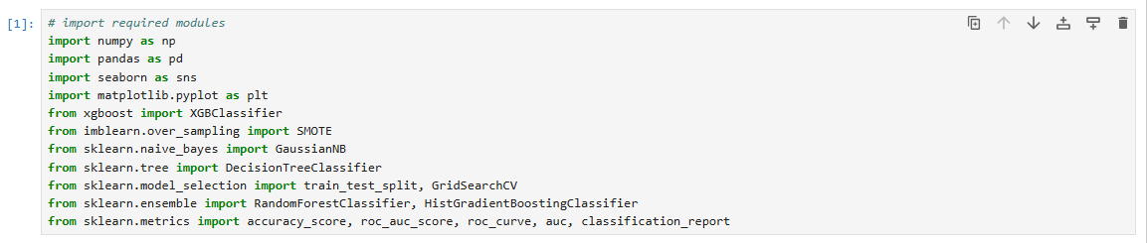

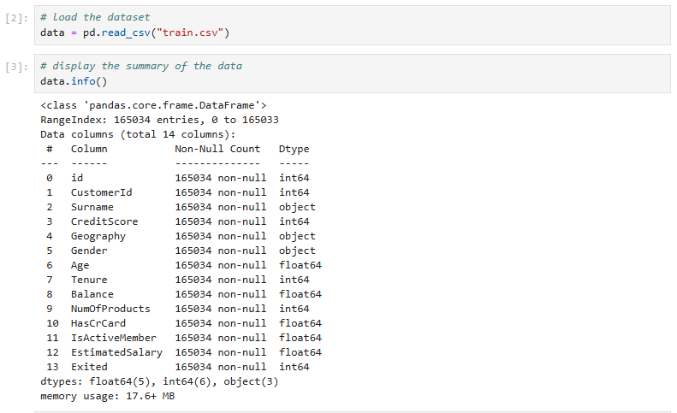

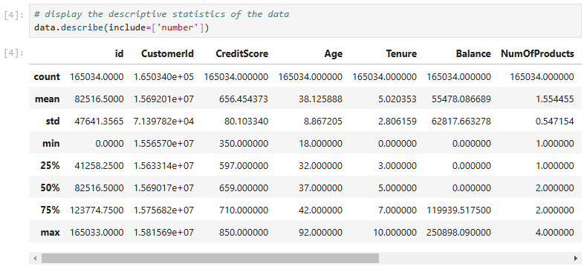

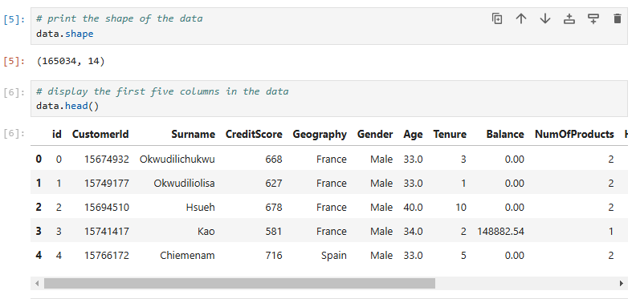

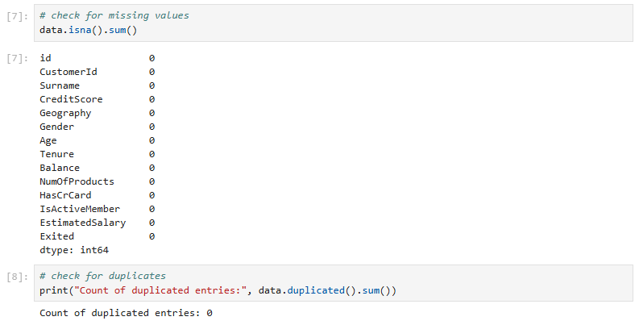

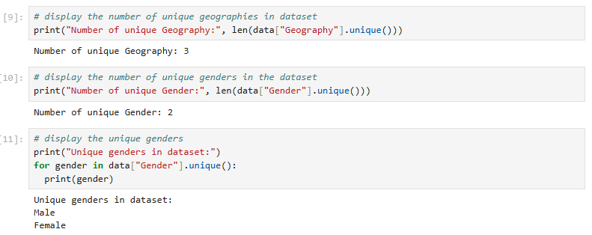

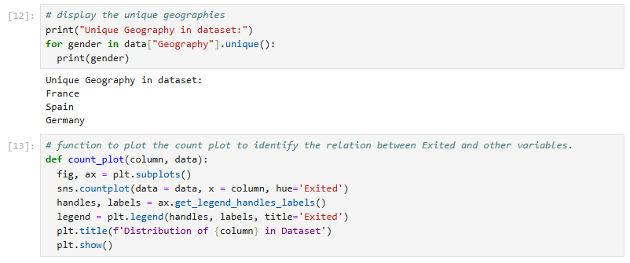



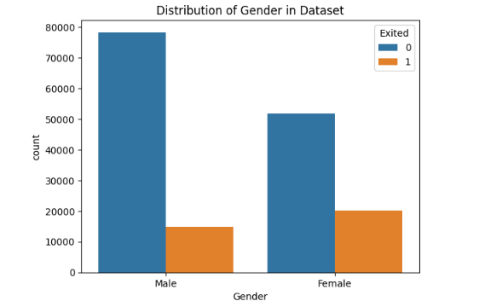

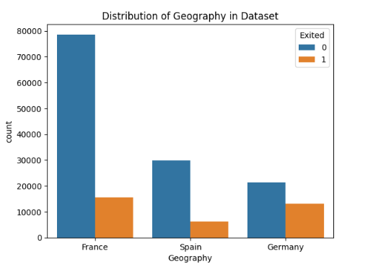

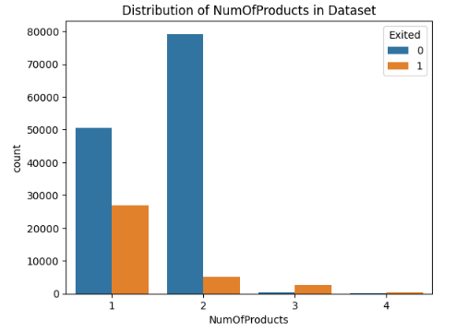

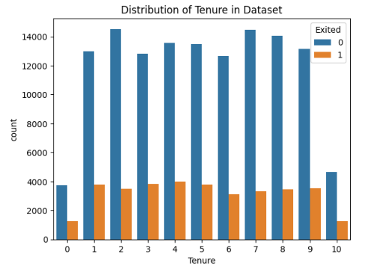

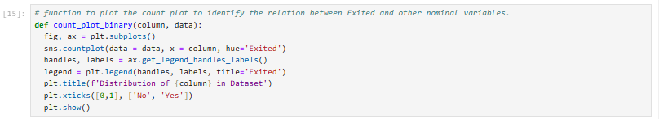

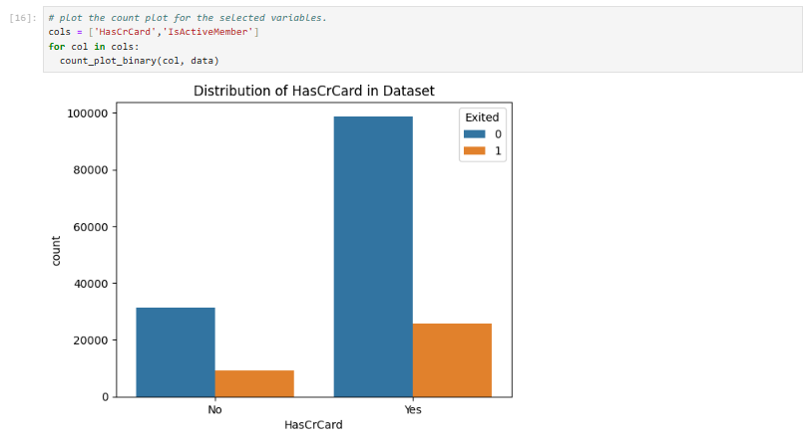

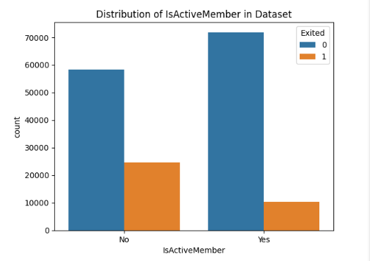

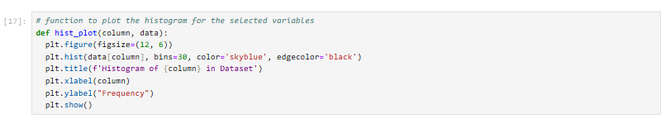

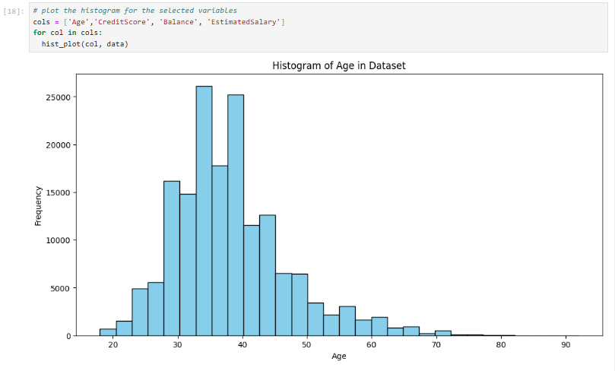

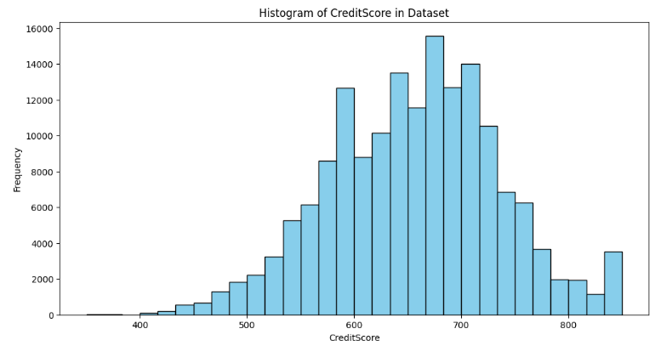

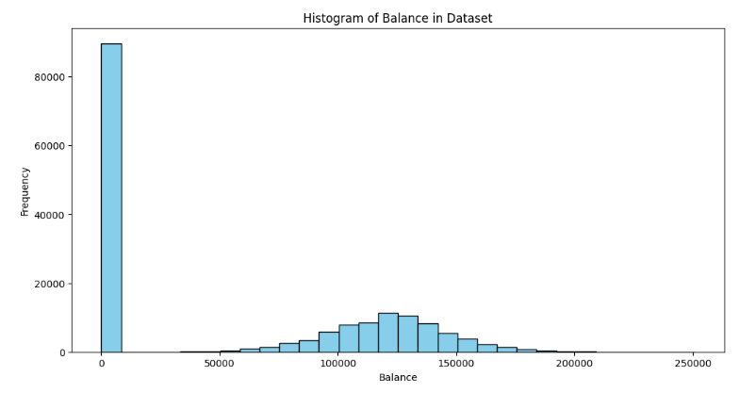

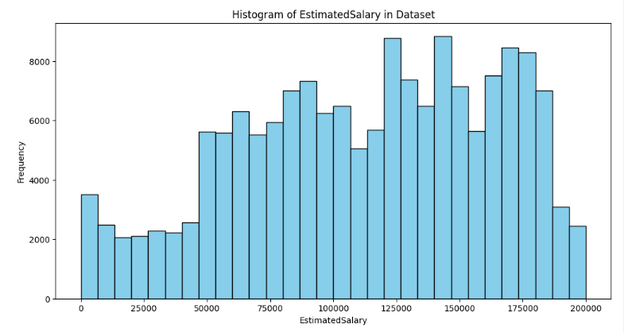

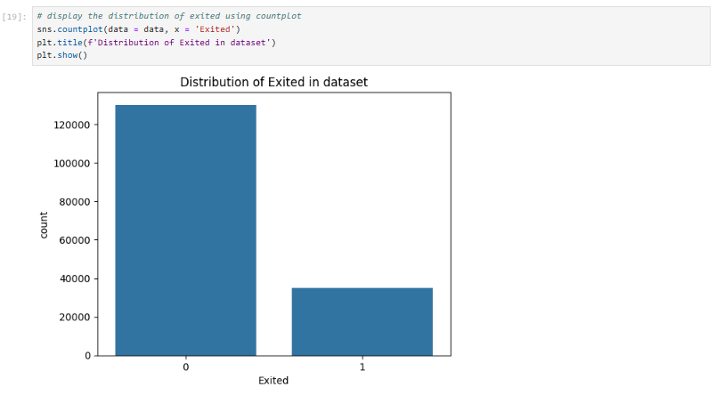

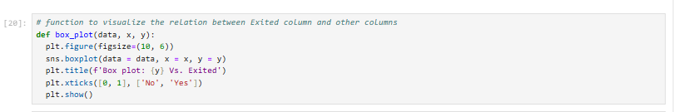

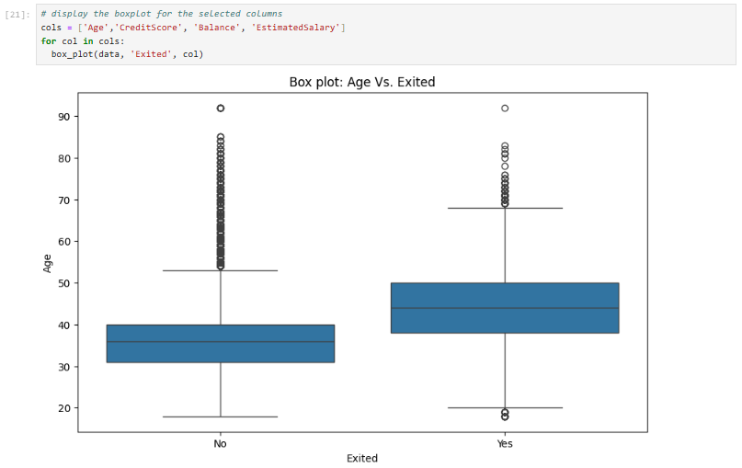

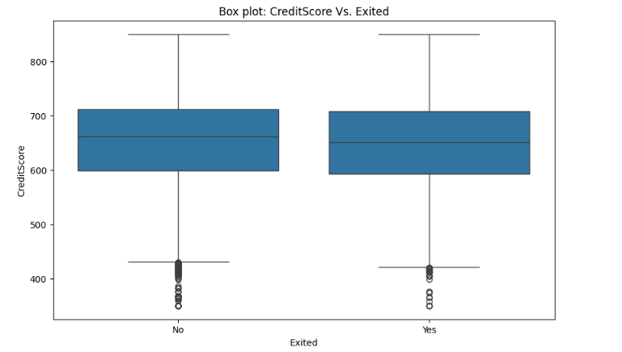

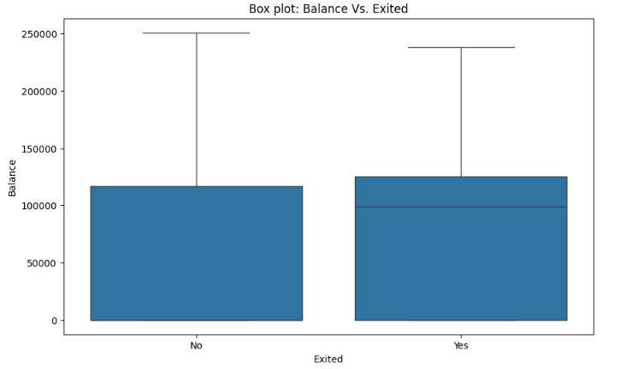

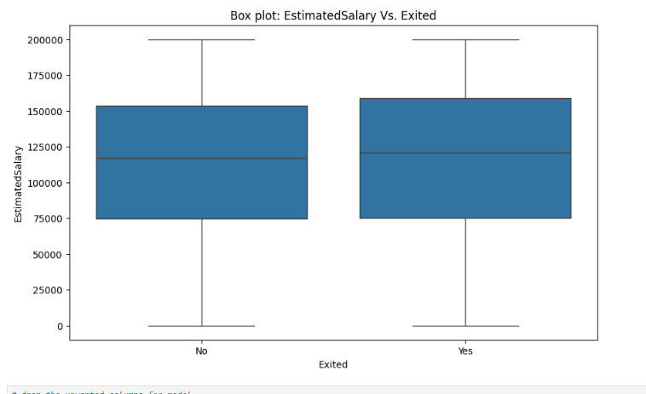

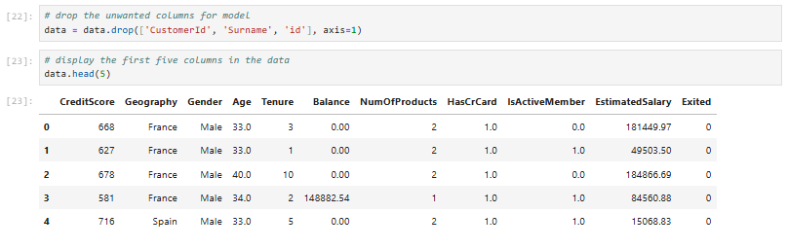

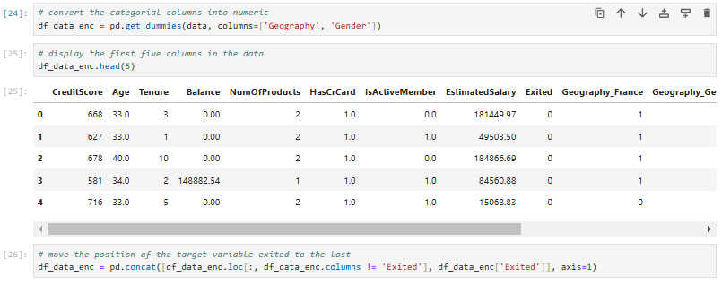

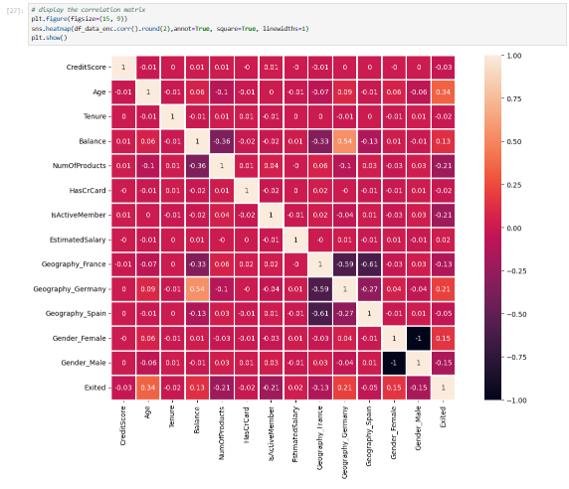

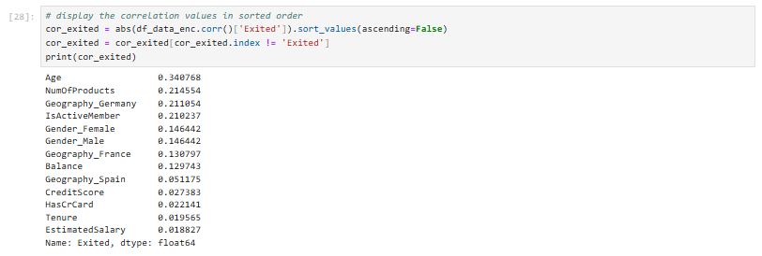

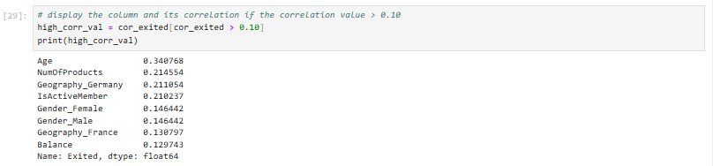

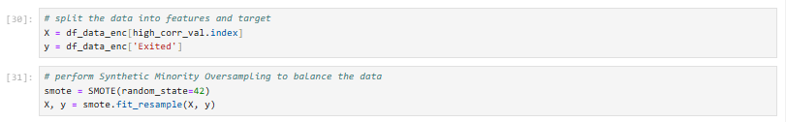

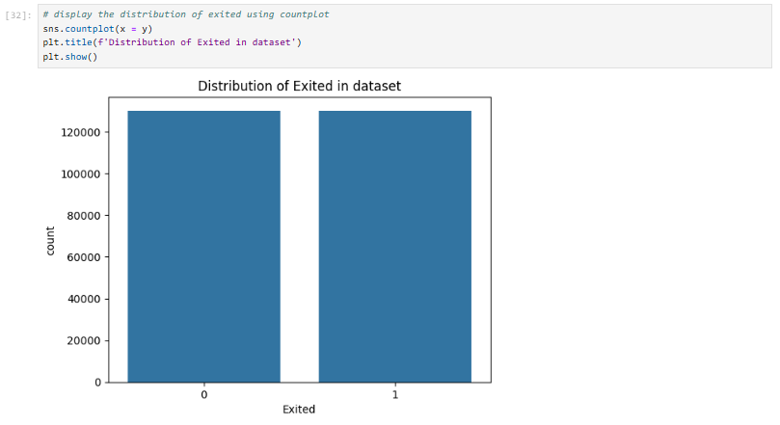

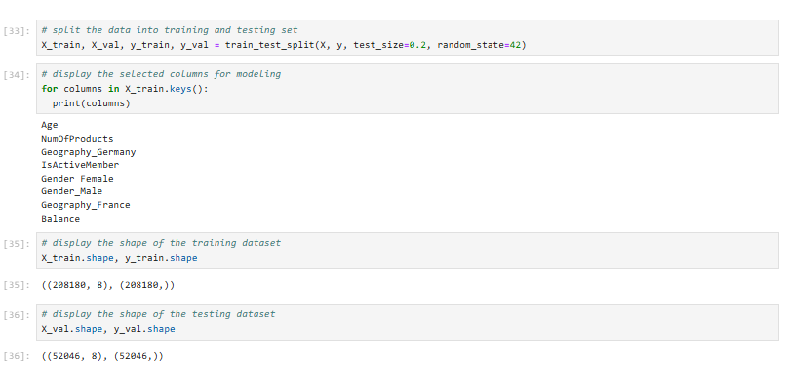

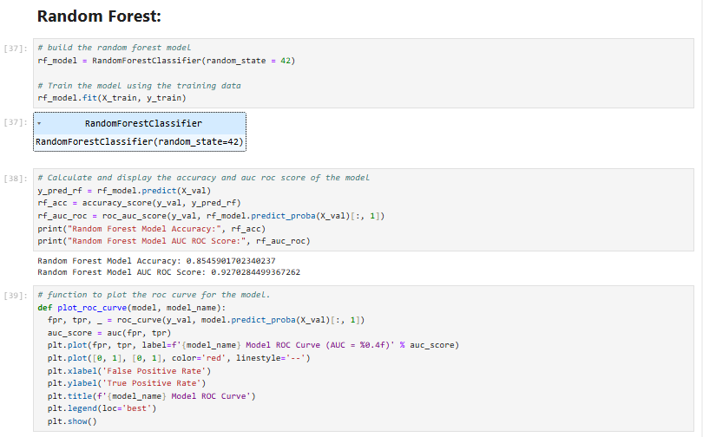

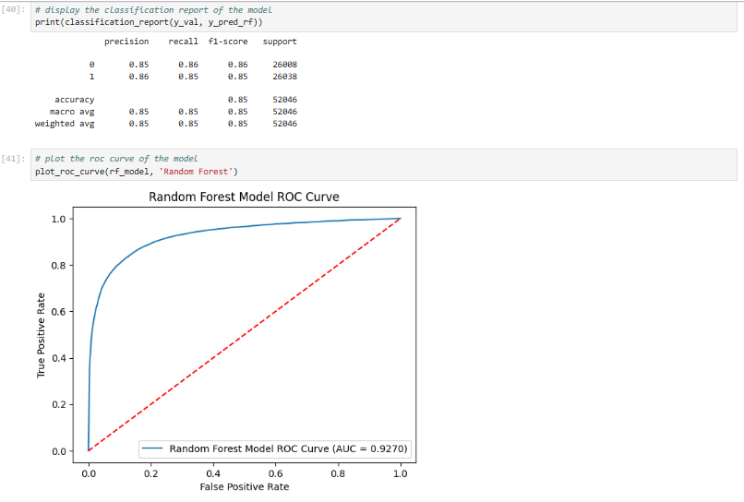

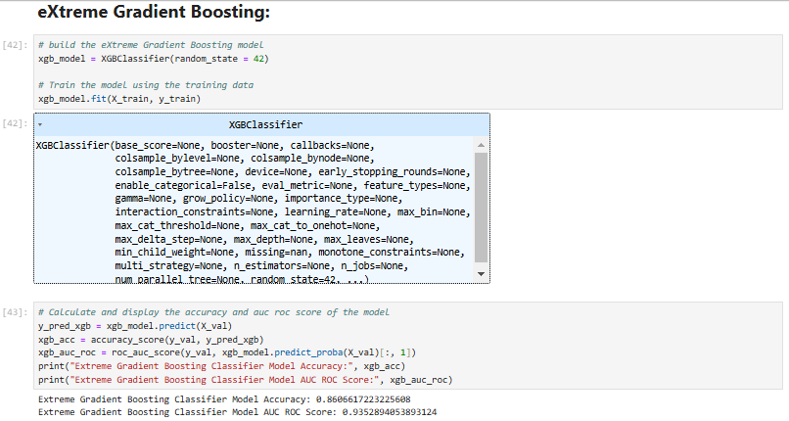

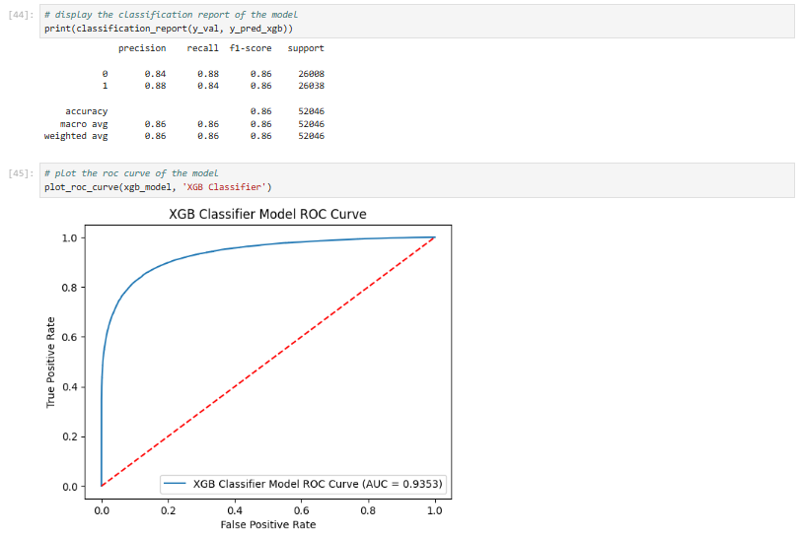

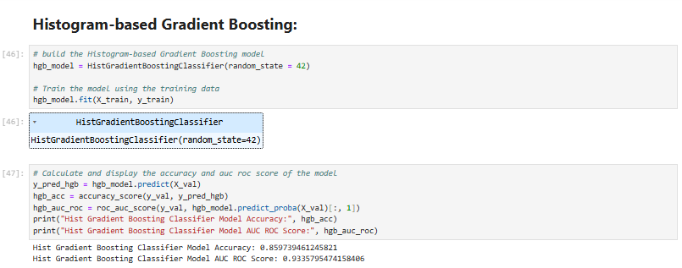

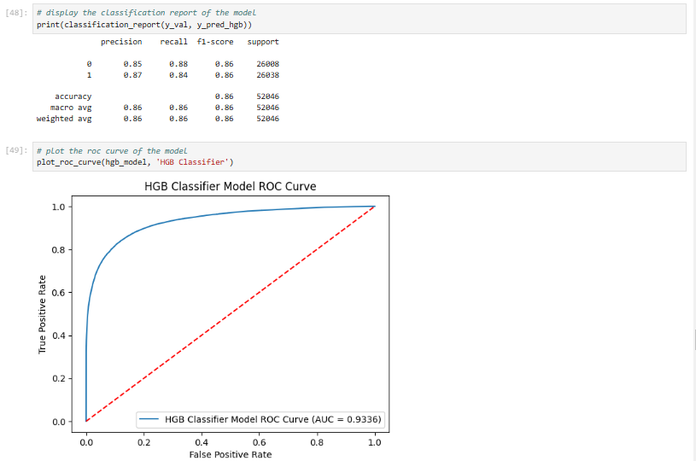

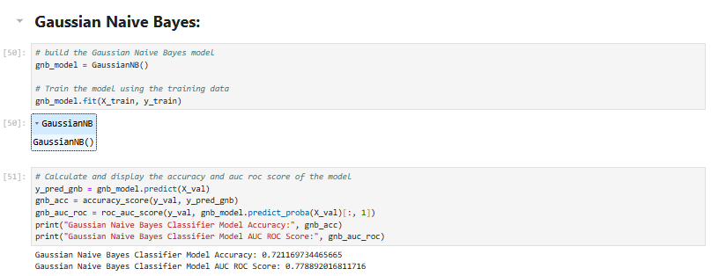

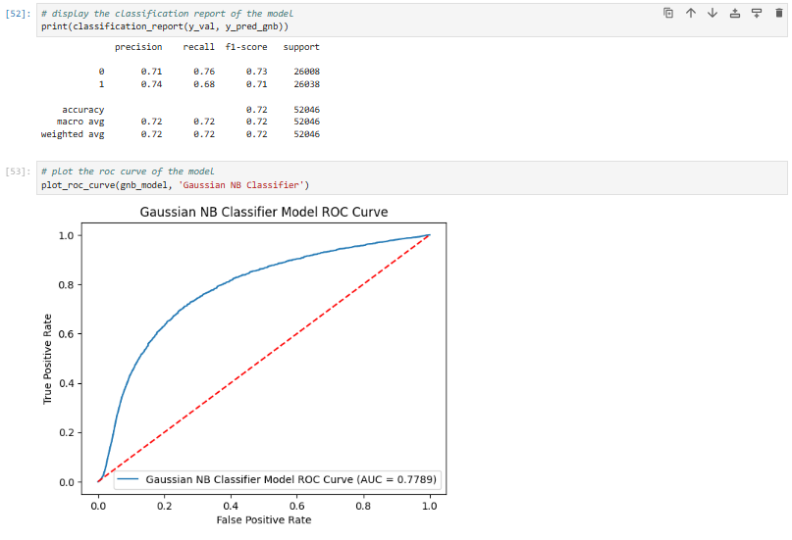

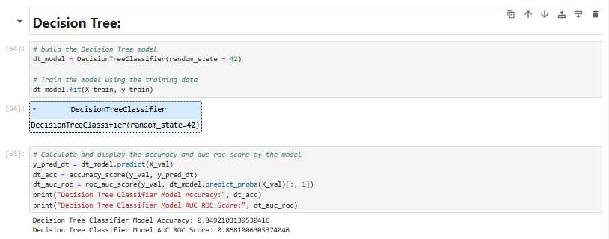

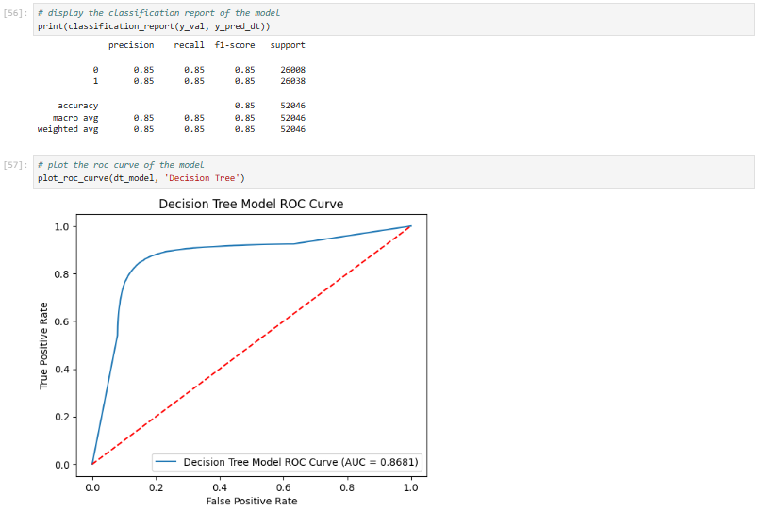

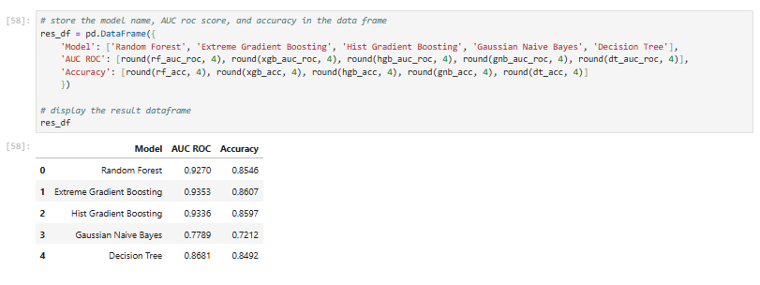

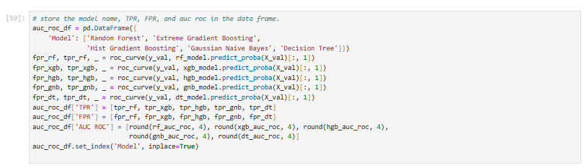

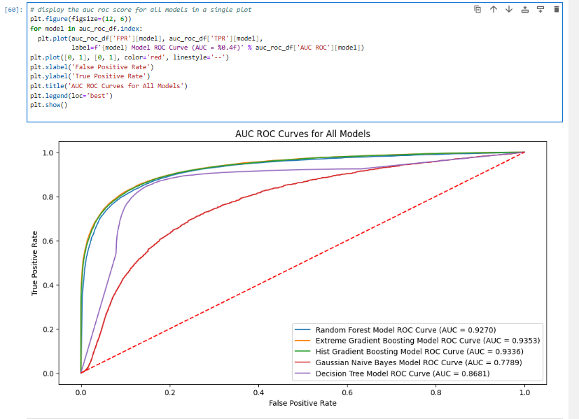

**Evidence for test case results**

**Test case #1:**



**Test case #2:**



**Test case #3:**

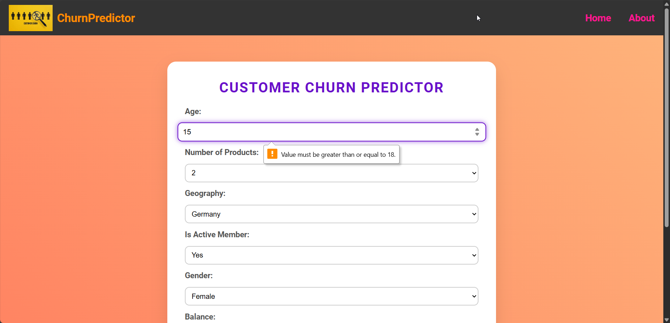

**Test case #4:**

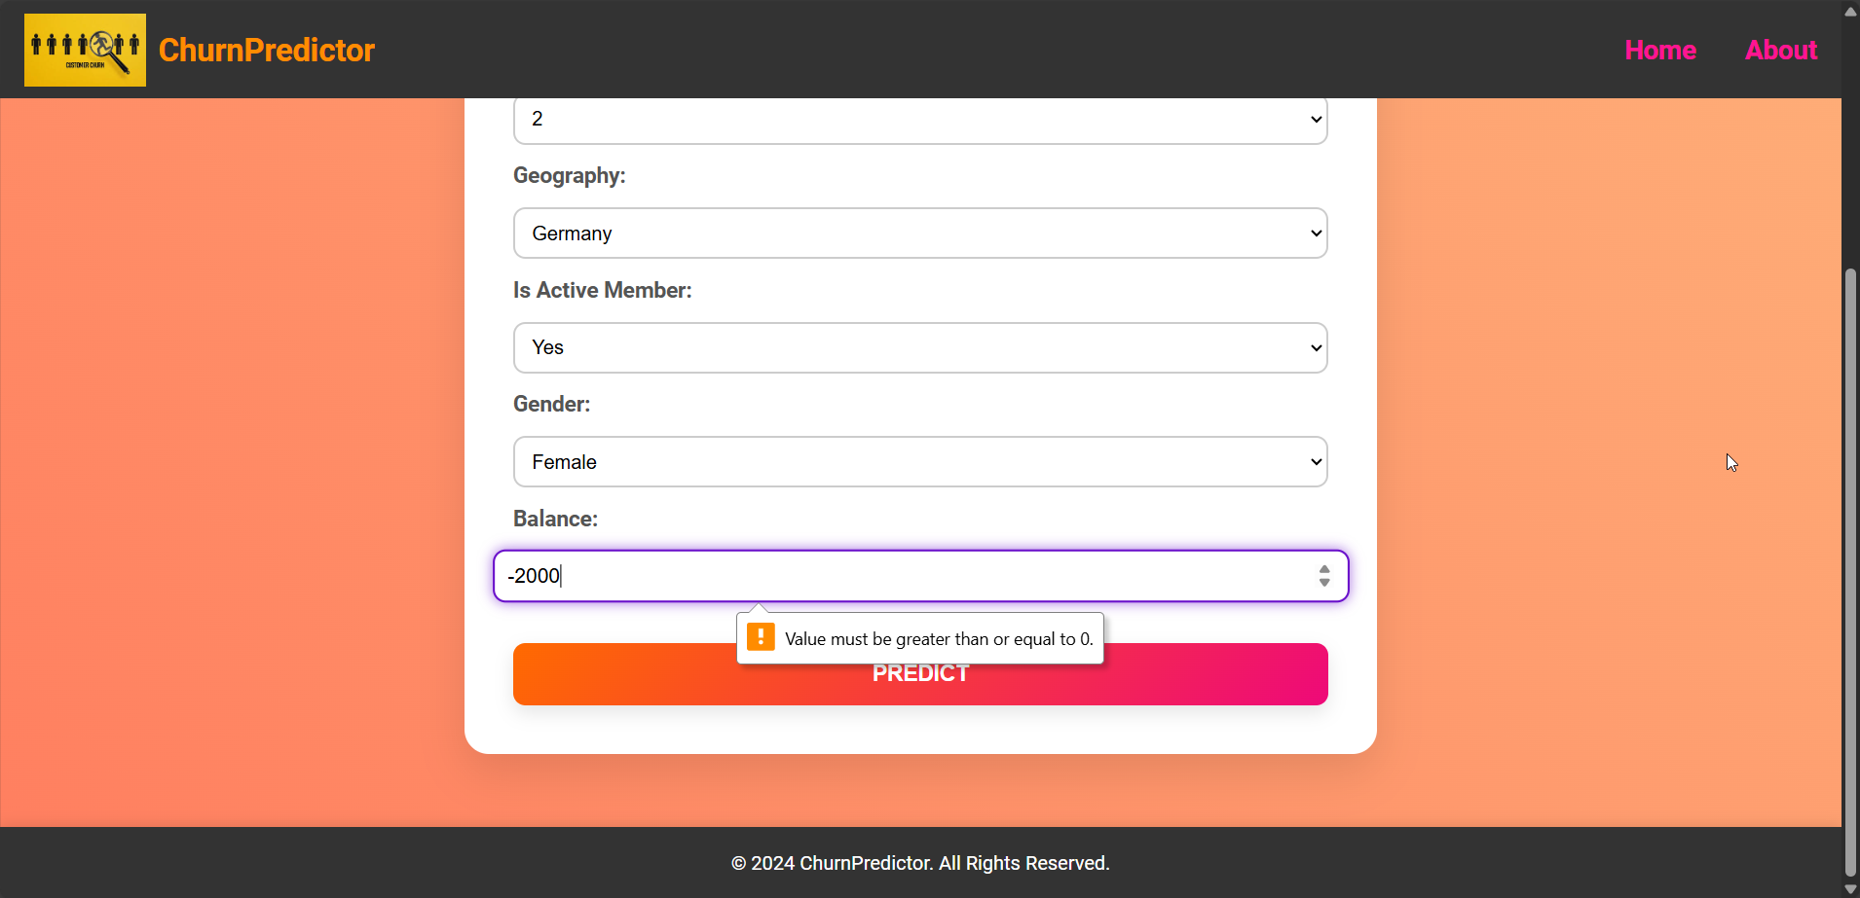

**Test case #5:**

